St Hugh’s church is now a collection and distribution point for the Lincoln foodbank.
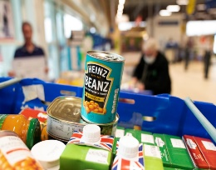
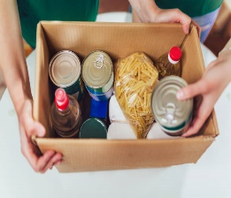
We are open
EVERY FRIDAY FROM 11.00 TO 13.00
FROM 3RD DECEMBER 2022
EVERY SATURDAY FROM 10.00 TO 13.00
DISTRIBUTION CENTRE
If you have a referral then please drop in when we are open to collect your food parcel.
If you are in need of a food parcel but do not have a referral then still please drop in for a chat to see if you are eligible.
In an emergency local delivery may be possible
If you cannot make the opening hours then please leave a message on the number shown below.
COLLECTION CENTRE
If you can give a donation of any canned goods, dried pasta, rice, tea, coffee, cleaning products or personal hygiene goods including sanitary products please just call in with your donation during our opening hours.
Thank you
FOR FURTHER INFORMATION PLEASE RING 01522 692378 AND LEAVE A MESSAGE
ST HUGH’S CHURCH, HAREWOOD CRESCENT, NORTH HYKEHAM LN6 8JG

