++++++++++++++++++++++++++++++++++++++++++++++++++++++++
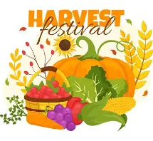
Services for Sunday 4 October 2026 Trinity 18 Harvest
St Paul’s 10am AAW Harvest Celebration Lead Anthea Darlington preach Rev Andy Smith: introduction to Stewardship campaign
St Andrew’s 11am Harvest Festival lead and preach Rev Avis Gordon
Services for Sunday 11 October 2026 Trinity 19
St Paul’s 10am Morning Praise lead David Martin: Stewardship 1
St Andrew’s 11am Morning Praise lead Rev Andy Smith: Stewardship 1
Thornleigh 10am Holy Communion preside Rev Mike Dyson: Stewardship 1
+++++++++++++++++++++++++++++++++++++++++++++++++++++++++++
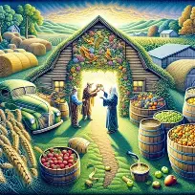1 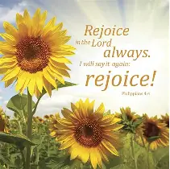2 3 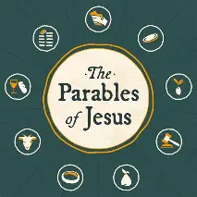4
Readings for Sun 4 October (P) Deuteronomy 26 (1) First fruits
Philippians 4: 4-9 (2) Rejoice in the Lord always
Readings for Sun 11 October Exodus 32: 1-14 (3) The golden calf
Matt 22: 1-14 (4) Jesus’ parables: eternal truths
Wed 7 Oct: Ps 117; Luke 11: 1-4 Wed 14 Oct: Ps 1; Luke 11: 42-46
++++++++++++++++++++++++++++++++++++++++++++++++++++++++++++++++++++++++++++++++++++++++++++++++
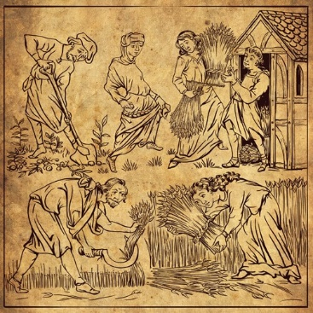
‘Harvest’ originally comes from the Old English word ‘hærfest’, meaning autumn, but has come to refer to the season for reaping and gathering crops. Harvest time was, historically, one of the most important periods of the year, as the quality of the harvest dictated whether people would have enough to eat for the coming year. In Britain, successful harvests have been celebrated since pagan times. Harvest time was exhausting, with farmers working around the clock, trying to ‘make hay while the sun shines’, and neighbouring farms racing against each other to be first to finish. The end of the harvest was a time for celebration – the horse bringing in the last cart load was decorated with ribbons and garlands of flowers, and farmers held a big feast known as the harvest supper. The tradition of celebrating harvest time with a thanksgiving service was introduced in 1843 by the Reverend Robert Hawker in Cornwall. The harvest festival service is held on or near the Sunday of the Harvest Moon and includes decorating churches with fruit and vegetables. As British people have come to rely less heavily on home-grown produce, there has been a shift in emphasis in many Harvest Festival celebrations. Increasingly, churches have linked Harvest with an awareness of and concern for people in the developing world for whom growing crops of sufficient quality and quantity remains a struggle; and more recently, for those in our own society who are living in poverty. Our gifts of goods go to support St James’ Pantry and of money to support Christian Aid’s Harvest of Hope appeal for people in other countries at the mercy of famine and conflict. Anthea Darlington
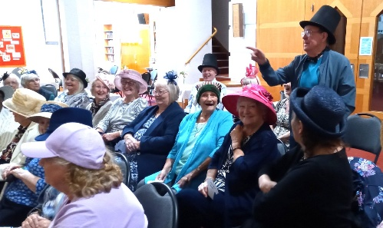
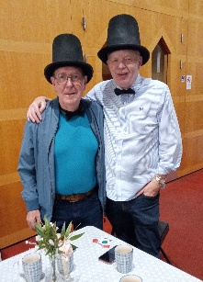
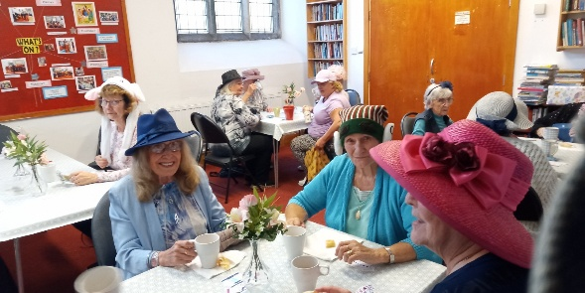
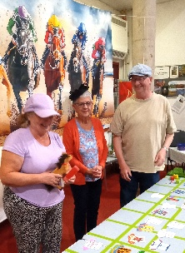

Fun with Time Out: at the recent ‘Time Out’ Derby- wonderful hats worn for the occasion ********************************************************************************************************* Our Prayers. In this Harvest season we pray: Lord of the Harvest, thank you for your generosity. Open our eyes to your good gifts and our mouths to give you thanks and praise. Forgive our careless attitudes toward creation and help us nurture the world you entrusted to us. Help us to share what we have, care for the world around us, and support those who cannot afford enough food. May our gifts bless all in need. Amen. ++++++++++++++++++++++++++++++++++++++++++++++++++++++ Our Stewardship Campaign begins with an introduction on 4 October at our Harvest celebrations, presentations at both churches on 11 October and again on 18 October. The presentations have been prepared to help you better understand the current financial position of the parish and the challenges we face going forward. Letters and pledge forms to complete will be distributed at session 2 with follow-up sessions at both churches on 15 November. Please be aware that currently we are not covering our costs, with a shortfall of £11,500 in 2025. Let us work together to remain as a Christian presence and beacon of hope in our two communities. We pray in the words of St Ignatius of Loyola: Take, Lord, and receive all my liberty, my memory, my understanding, and my entire will. Everything I have is Yours; to You I return it. Give me only Your love and grace, that is enough for me. Stir us, Lord, to venture boldly, to use our gifts wisely, and to share generously, so that our stewardship bears witness to Your love. Amen. ++++++++++++++++++++++++++++++++++++++++++++++++++++++++++++++++++++++++ Income Survey: it’s that time of year again when the Diocese carries out its annual income survey on which our Parish Share is based. Forms will be given out at services this month: we need 37 responses from St Paul’s and 6 from St Andrew’s. If you are a regular attender i.e. more than once a month, please complete a form. +++++++++++++++++++++++++++++++++++++++++++++++++++++++++ St Paul’s School held its harvest celebration in school on 2 October with enthusiastic singing and generous donations of goods to Salford charities: thankyou to parents, staff and children, and to the parish Leadership Team for leading the service. +++++++++++++++++++++++++++++++++++++++++++++++++++++++++++Monthly fundraising and social event programme update 2026 Sept: Macmillan Coffee Morning raised £313.00 Congratulations everyone! October: Stewardship campaign St Paul’s 4,11,15/18 October; St Andrew’s 4,11,15 October Nov: Christmas wreath-making Sun 29 Nov-max 25 to make wreaths; others just watch! +++++++++++++++++++++++++++++++++++++++++++++++++++++++++ Details of Other Services and Events for the next 2 weeks Tue 6 Oct: St Paul’s Time Out 1.30pm Harvest celebration: harvest history, quiz and games Wed 7 Oct: St P 10am Holy Communion with Rev Dr Simon Mars of the Mission Community Thur 8 Oct Theology on Tap 7.30pm at the Red Lion Prestwich- Mission Community discussion Fri 9-Mon 12 Oct: Parish weekend away at Grange-over-Sands Tue 13 Oct: Bible Study 7pm 5 Moorside Road Jonah and the ‘whale’: all you need to know Wed 14 Oct: St Paul’s 10am Holy Communion with Rev Mike Dyson Thur 15 Oct: Home group 7pm 47 Agecroft Road

