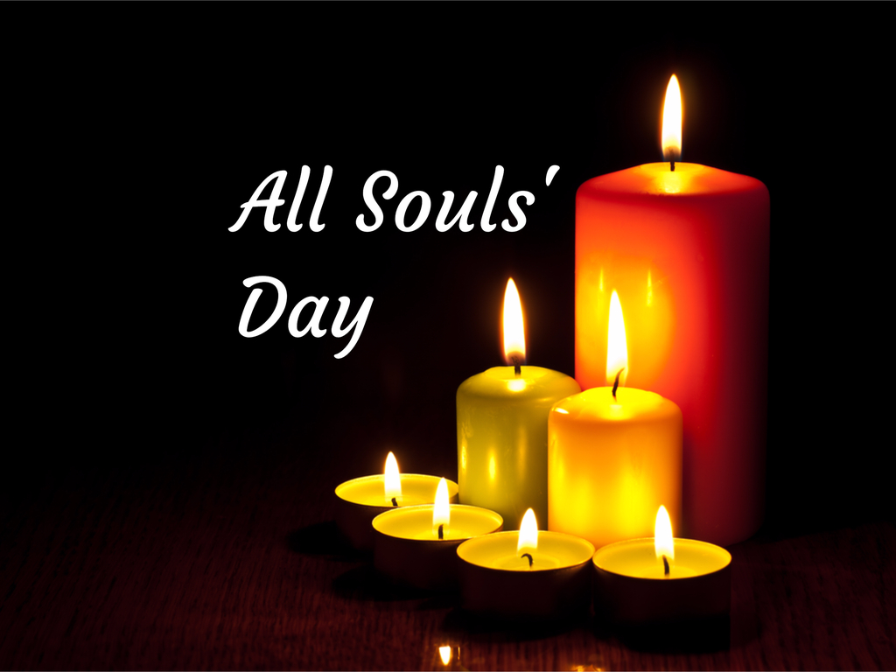

Sunday 1st November
At Christ Church
At 10a.m.

Come to our service today to
remember our neighbours and
friends who have died this year and
all those who have made an impact
on our world and our lives before
they died.

There will be hymns, readings,
prayers and a short Holy
Communion Service.

