Remembrance for All
A special Remembrance Sunday service for everyone
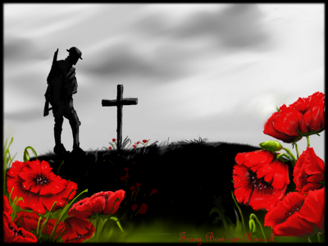

10.45 am
Sunday 8 November
St Mary and St Lambert Stonham Aspal and Mickfield
Wear your poppy......

