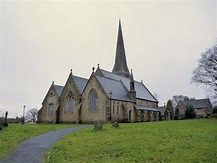
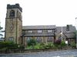
The Benefice of Healey, Hamer and Belfield
St Ann’s, Belfield

“Though I walk through the valley of the shadow of death, I will fear no evil, for You are with me, Your rod and staff they comfort me.” Psalm 23 v4

All Souls’ Remembrance
Wednesday, 28th October
10.30am
St Ann’s, Belfield

All are welcome to join us at this time as we remember and give thanks for those we love but see no longer.

For more help, visit
https://www.churchofengland.org/prayers-moment

