
Revd Olive Stevens, Assistant Rural Dean, and Revd Jess Lancaster invite you to join them for a ZOOM COMPLINE SERVICE.
8pm Thursdays for 30 mins.

Please feel welcome to join whenever you can do so- this is a Trigg Major Deanery Compline Service. Prayer Requests are welcome. Please send to Revd Olive, if unable to attend.
If you would like to join in follow the link -It will remain the same link each week

Olive Stevens is inviting you to a scheduled Zoom meeting.
Join Zoom Meeting
https://us04web.zoom.us/j/72531125464?pwd=faZ0ZKi178yHycXxh0HzcRKqo3qxBP.1
Meeting chat link
https://us04web.zoom.us/launch/jc/72531125464
Meeting ID: 725 3112 5464
Passcode: 3J92hN

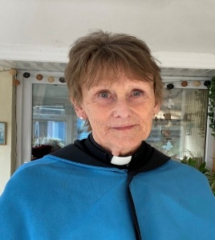
ASSISTANT RURAL DEAN
Revd Canon Olive Stevens
Tel: 07480576525
Email: olivestevens5@gmail.com

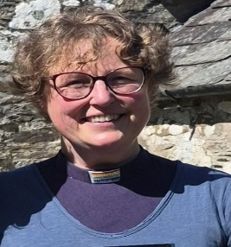
Revd Jess Lancaster
Non-Stipendiary & limited contact time available
Tel 01566 782119
Email: reverendjesslancaster@gmail.com

