St Kenelm’s Light Party.
This year to be held at:
Clifton Village Hall
Saturday 31st October
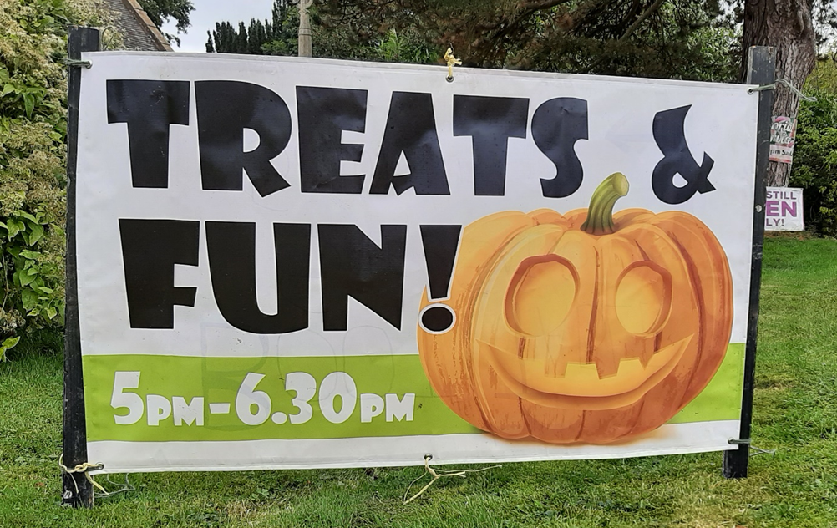

Drop in for a warm welcome, children’s activities, and hot refreshments while trick and treating. 5pm-6.30pm

