SHINE A LIGHT

Saturday 28th November
2.30-4.30p.m.

Come along to Christ Church to enjoy the spectacle and delicious refreshments. There will be activities for youngsters.

We need creations to display, please!
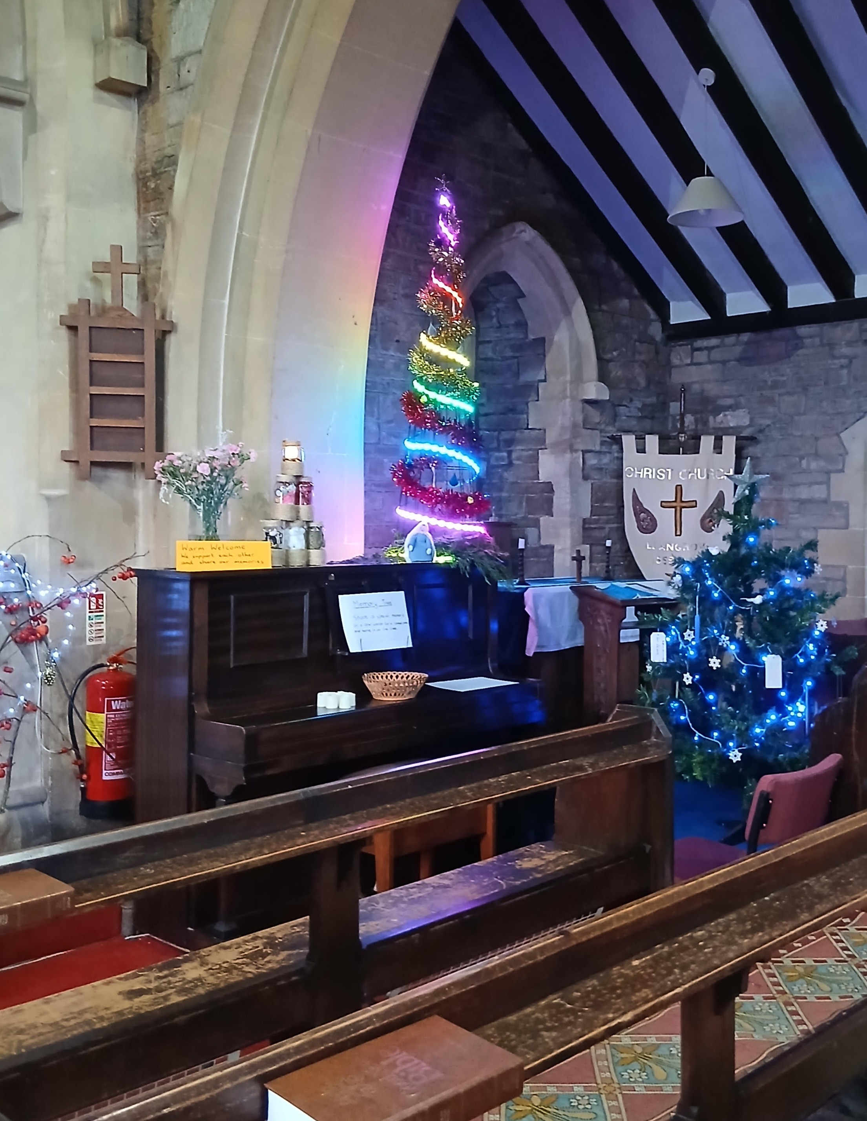
Groups could make a creation to represent their group or
individuals are welcome to contribute. Creations will be returned to owners after the weekend, unless you would like them to stay in church as we prepare to
celebrate the Christmas
season.

