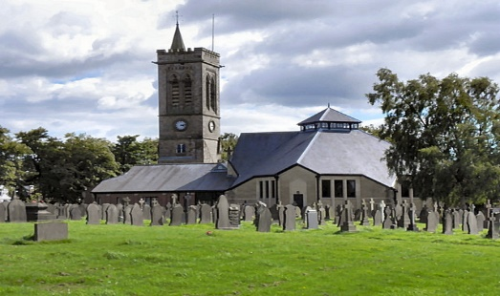
St. Bartholomew’s Church,
Westhoughton

Parish Memorial Service
Sunday 1st November
2:00pm
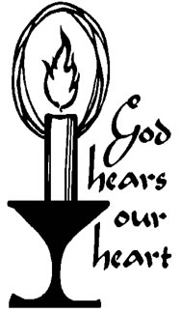
A service at which we remember our loved ones by name, in silence or by lighting a candle

All Welcome

