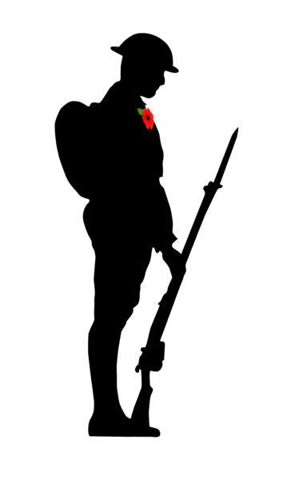

Meet in Village Square at 2.30 for parade to War Memorial and laying of wreaths
Followed by Service in St Mary’s Church at 3.30pm which will include a centenary celebration of the East Window

REMEMBRANCE SUNDAY
8th NOVEMBER

