CHURCH OF ST GREGORY THE GREAT MORVILLE

HARVEST FESTIVAL SERVICE
SUNDAY 11 OCTOBER 11.15am

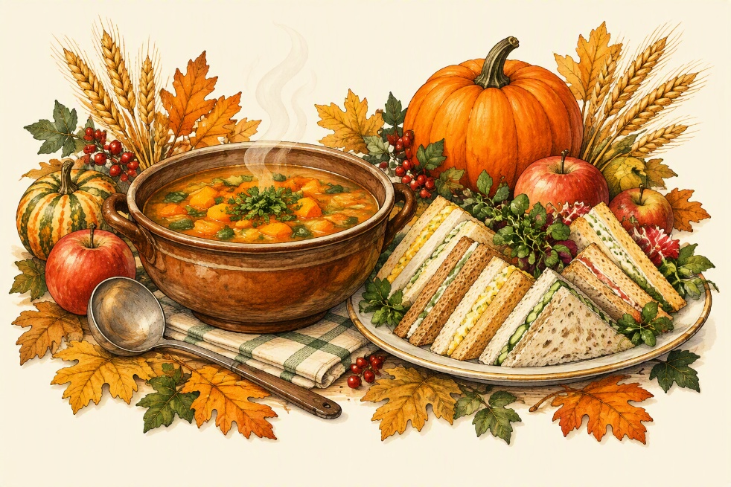
And join us after the service for a warm and welcoming
HARVEST LUNCH
SOUP • SANDWICHES
12.30–1.30 pm in the church
EVERYONE IS WELCOME
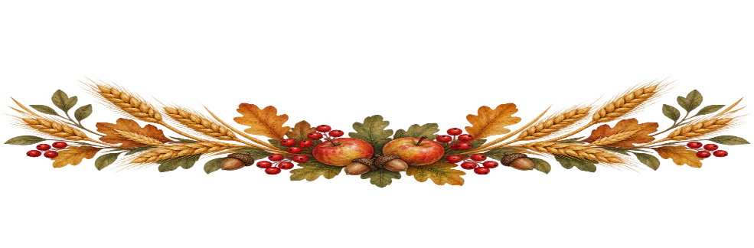
Donations collected will help fund the maintenance of Morville Church.

