

W. A Mozart’s
Requiem Mass

A service to commemorate the faithful departed

St James Norlands church

Sunday 1st November 2026
at 5pm

With the St James’ Singers

All are welcome
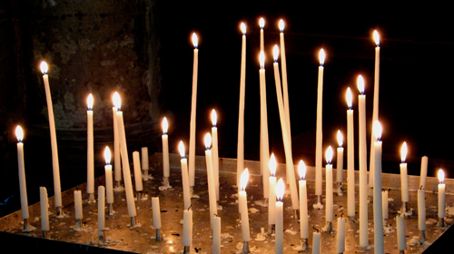

‘For those we love, but see no longer…”

