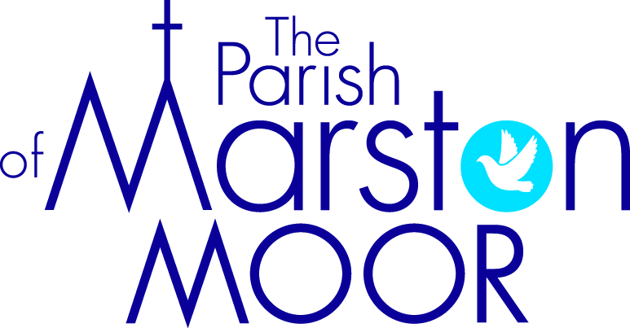 | Askham Richard | Bilbrough | Long  Marston | Rufforth | Tockwith
1st  All Saints’ Day | 6:00pm  All Souls Service | 9.00am  Holy Communion | 8.30am  Breakfast Praise | 11.00am  Holy Communion | 11.00am  Refresh Service
8th  3rd Sunday before Advent | 9.00am  Remembrance Service | 10.00am  Remembrance Service | 5.00pm  Remembrance Service | 10.50am Remembrance Service | 10.50am  Remembrance Service
11th | Act of Remembrance, Long Marston 10.45am
15th  2nd Sunday before Advent | 10.00am  All Age Worship | 10:00am  Shoe Box Service | 11.00am  Creative Church | 11.00am  All Age Worship | 6.00pm  BCP Evensong
22nd  Christ the King | 9.00am  Holy Communion | 10.00am  Family Praise | 11.00am  All Age Worship | 11.00am  Holy Communion | 11.00am  Informal Parish Praise
29th  1st Sunday of Advent | Parish Holy Communion  Bilbrough  10.00am

