You are invited to

These We Have Loved

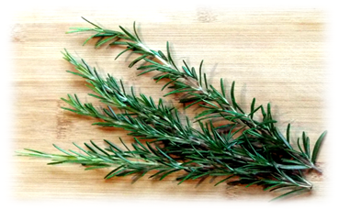

These We Have Loved
is a Service of Remembering for
the people we have loved and who have died,
and whose memory we still cherish.

Sunday 1st November 2026 at 4.00 pm
at St Peter’s Church, Evercreech
Followed by refreshments

Many of us have mourned the death of family members or friends in recent months and years. Many still grieve for someone who died many years ago. However recent or distant your loss, you are invited to These we have loved – a service of remembering – on Sunday 1st November at 4pm in St Peter’s Church, Evercreech.

These we have loved is a gentle, short service, followed by tea, cake, and conversation (or a chance to sit quietly). You can light a candle. You can ask for the name of someone who has died in the past few years to be read out.

You can write names on the lists that will be in St Peter’s Church from mid-October. If you prefer, you can email names to Anne at sear.a@btinternet.com with These We Have Loved in the subject line, by 30th October, please. Please remember to include the year that the person died. The date of death and their age are optional.

We look forward to welcoming you at this service.

