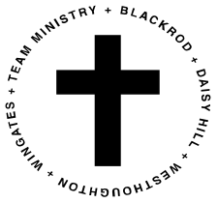
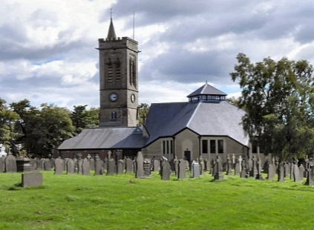
St. Bartholomew’s Church,
Westhoughton

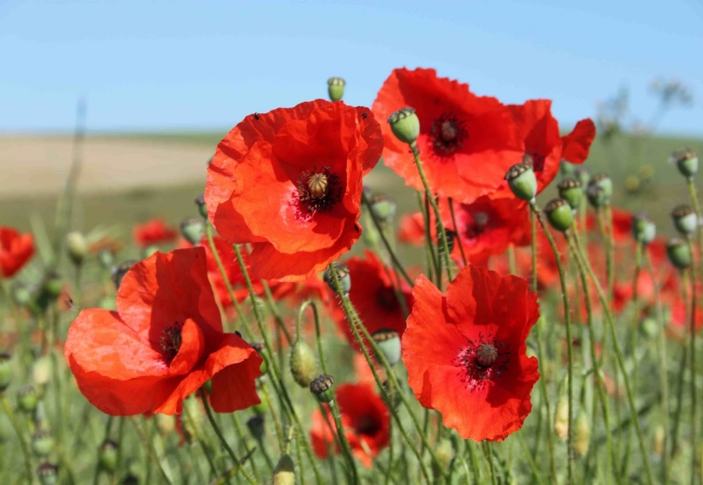
Remembrance Sunday
Sunday 8th November

10:00am Civic Service
**** NOTE: Attendance limited ***
11:00am Laying of Wreaths & Two Minutes Silence at the War Memorial
11:30am Holy Communion Service
There is NO SERVICE at St. George’s or St Thomas’ churches this Sunday

