Holbrook St Michael’s Church
Harvest Fish and Chip Lunch

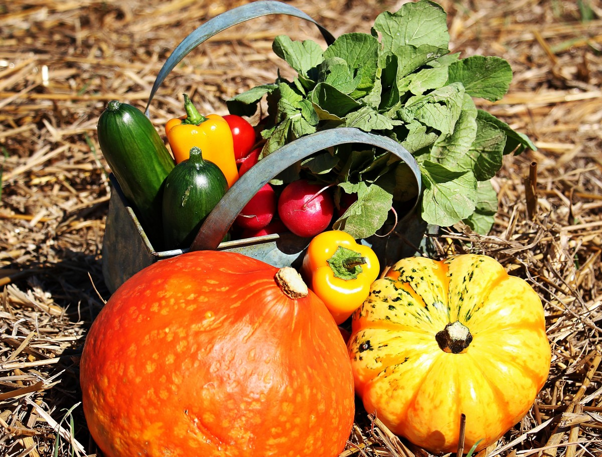

Saturday 3rd October 2026
From 12 noon till 2.00 p.m. in the Arkwright Hall.
Booking before Monday 27th September is essential.
Tickets: Adults £14.00 Young people £7.00
Please get your ticket from John (07890 241673) or Penny & Richard (07908 547331).

