Learn CPR. Use a Defib. Save a Life.
  - Community CPR & Defibrillator Awareness Session
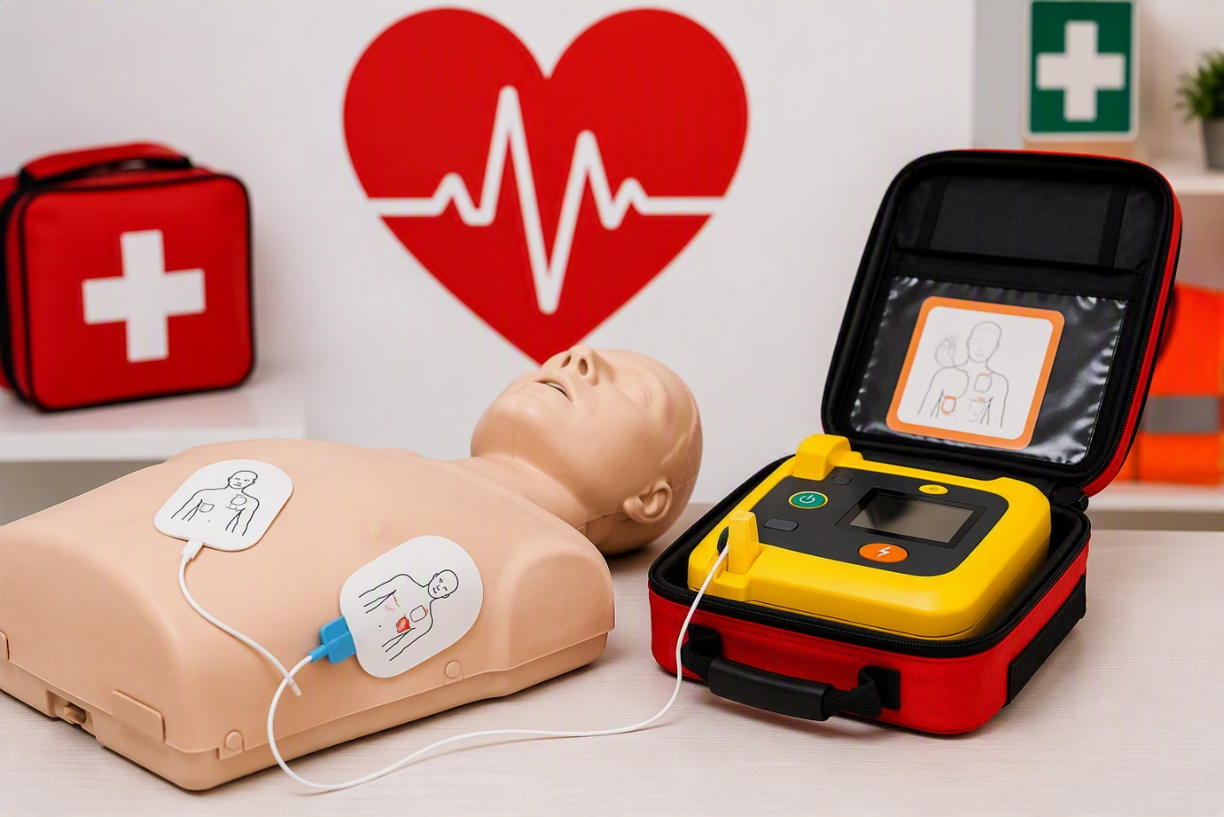
Arranged by Feckenham Parish Council
Delivered by Redditch and Bromsgrove First Responders
Registered Charity 1200915
Wednesday 16th September at 7.30pm
Venue: Feckenham Village Hall, Back Room
To book: Contact the Parish Clerk, Jane, on 01527 892522 or email clerk@feckenham-parishcouncil.gov.uk

Would you know what to do in an emergency?
This practical session will help you understand how to respond if someone suffers a cardiac arrest, including how to give CPR and use a defibrillator with confidence.

What you’ll learn
- How to recognise cardiac arrest
- How to perform effective hands-only CPR
- When and how to use a defibrillator
- What to do while waiting for emergency services
- How quick action can make a life-saving difference
Don’t wait for an emergency — book your place today.
No previous first-aid experience needed.

