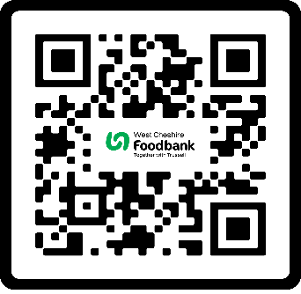
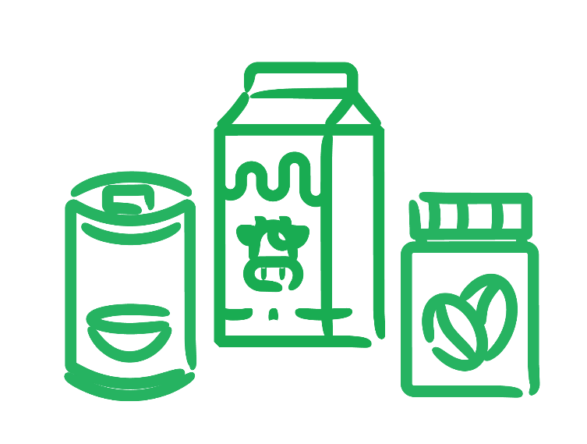


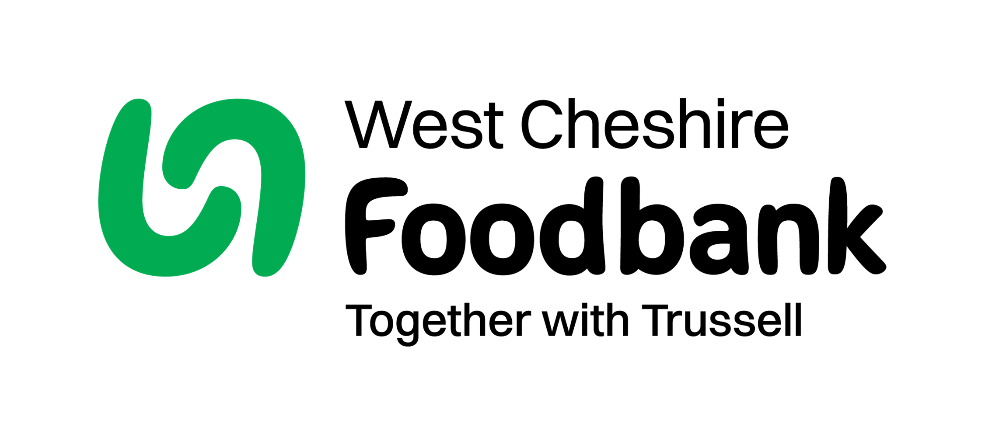
Tinned meat or meat meals Tinned veg/potatoes/tomatoes
Cooking sauces
Coffee
Milk (UHT)
Pot/Instant noodles
Fruit juice (long-life)
Tinned pudding/custard
Jam/spreads
Biscuits

West Cheshire Foodbank
Westcheshire.foodbank.org.uk
Harvest appeal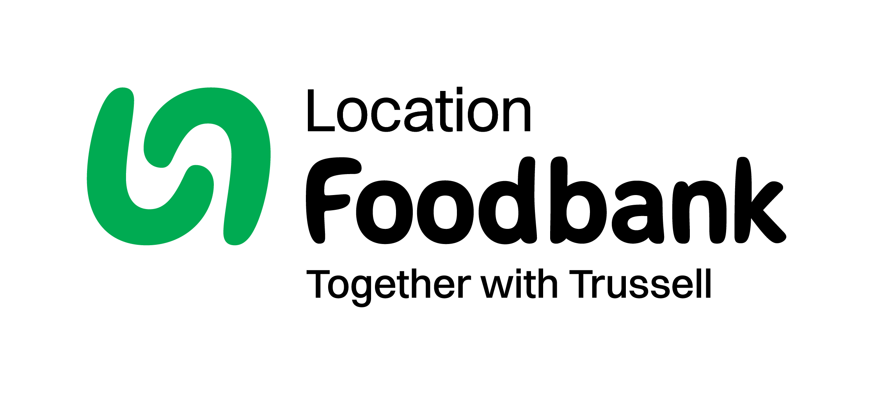

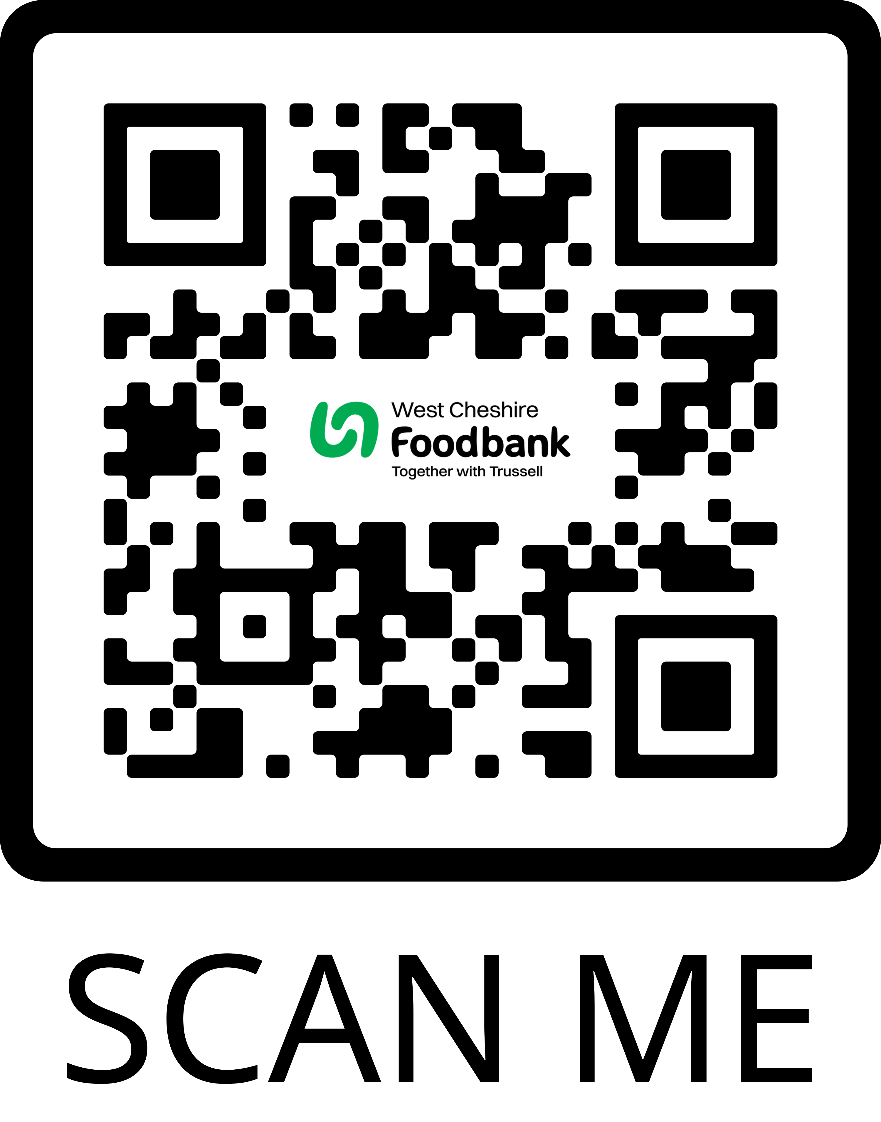

Help to cover the costs of storing and distributing food, as well as developing sustainable projects.

Donate an item or two from our shopping list, ensuring we can provide food for people facing hardship in your community.

Shopping list
Donate money
Donate food
Help support your food bank this Harvest

In the three weeks leading up to Harvest, the food bank will provide over food parcels for local individuals and families facing hardship.
Registered Charity in England & Wales (1150934)

