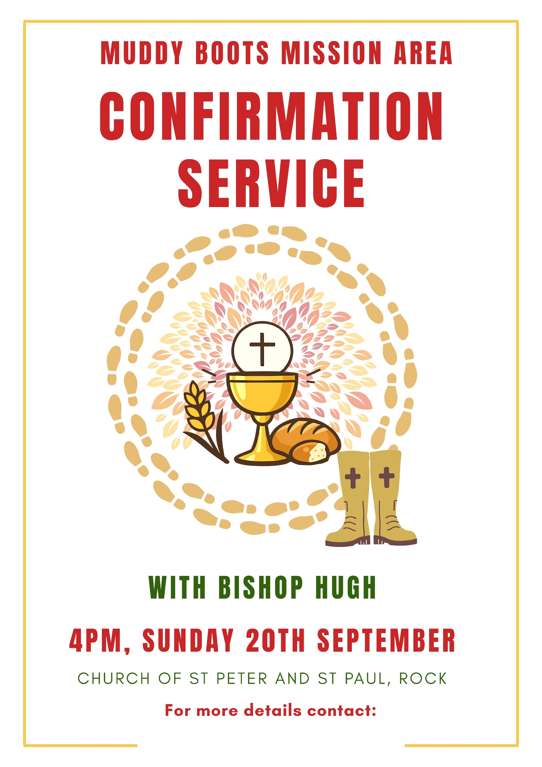
Rev Sallie Butcher:
revsallie@wyreforestwest.org.uk 01299 896837

