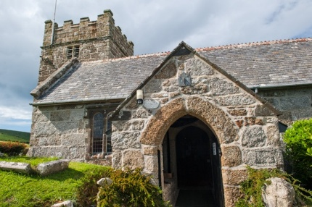
Sunday 20th September 11.00 a.m. Harvest Thanksgiving Service
followed by Harvest Lunch

CHURCHWARDENS:
Maureen Stevens Tel:01736 795862 email: donmaur2@hotmail.co.uk
David Billingham Tel: 01736 330289 email: david.billingham@yahoo.co.uk

TOWEDNACK PARISH
CHURCH SERVICES
AUGUST and SEPTEMBER 2026

DATE | SERVICE | TAKEN BY | READINGS | READERS | SIDES- PERSON
AUGUST 2nd  Trinity 9  White | 11.00 am Holy Communion | Rev. Sharon Chalcraft | Romans 9. 1-5  Matthew 14. 13-21 | D. Billingham  Ellen Carter* | Julie Curtis
9th  Trinity 10  Green | 11.00 am  Holy Communion | Rev. Jo Thomas | Romans 10.5-15  Matthew 14.22-33 | Roger Garside* | Bill Blewett
16th  Trinity 11  Green | 11.00 am  Holy Communion | Rev. Ian Lowell | Romans 11.1-2a, 29-32  Matthew 15. 21-28 | Barbara Daniel  Julie Curtis* | Linda Cook
23rd  Trinity 12  Green | 11.00 am  Service of the Word | Worship Leader  Julie Curtis | Romans 12.1-8  Matthew 16.13-20 | tba | D. Billingham
30th  Trinity 13  Green | 11.00 am  Holy Communion UNITED SERVICE at | Rev. Jo Thomas  ZENNOR | - | - | -
SEPTEMBER 6th  Trinity 14  Green | 11.00am  Holy Communion | Rev. Sharon Chalcraft | Romans 13.8-14  Matthew 18.15-20 | D. Billingham  Ellen Carter* | Keith Pester
13th  Trinity 15  Green | 11.00 am  Holy Communion | Rev. Leslie Attwood | Romans 14. 1-12  Matthew 18.21-35 | Linda Cook  Roger Garside* | Julie Curtis
20th  Trinity 16  Green  HARVEST THANKS | 11.00 am  Holy Communion  GIVING | Rev. Sharon Chalcraft | Psalm 65  John 6. 5-13 | Barbara Daniel  Julie Curtis* | Linda Cook
27th  Trinity 17  Green | 11.00 am Holy Communion | Rev. Elizabeth Foot | Philippians 2.1-13  Matthew 21.23-32 | Ellen Carter* | D. Billingham
OCTOBER 4th  Trinity 18  Green | 11.00am  Holy Communion | Rev. Sharon Chalcraft | Philippians 3. 4b-14  Matthew 21.33-46 | Linda Cook  Roger Garside*  *Intercessions | Bill Blewett
Harvest
Thanksgiving
Sunday 20th September
11.00 am
Garden Party
Saturday 15th August
2pm to 4pm
Churchtown Farmhouse Garden

