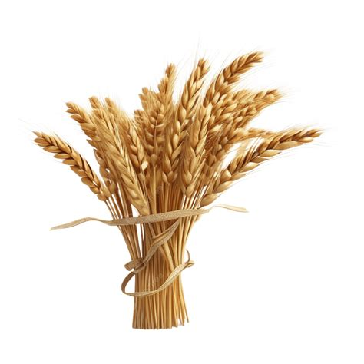
Harvest Festival

St Peter’s Church
11.00 am
Sunday 20th September
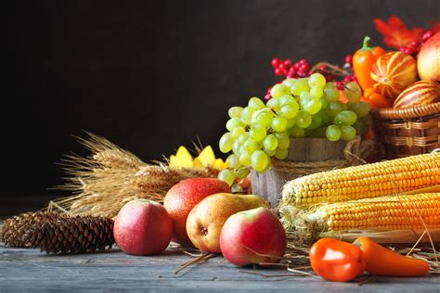
Please do come and join us!

