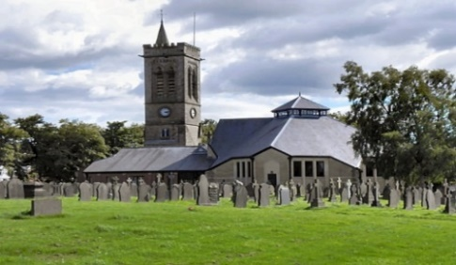
The Parish of St.Bartholomew, Westhoughton

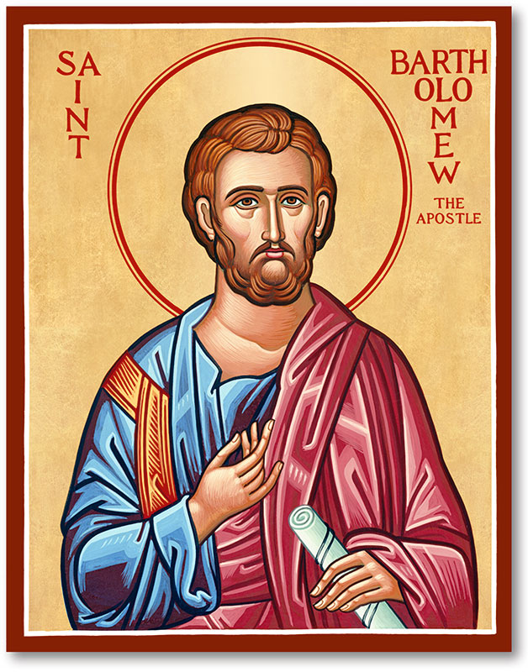
St. Bartholomew’s Day
Sunday 23rd
August
11:00am
Holy Communion Service celebrating the life and work of this parish church
Followed by a bring and share lunch

All Welcome

