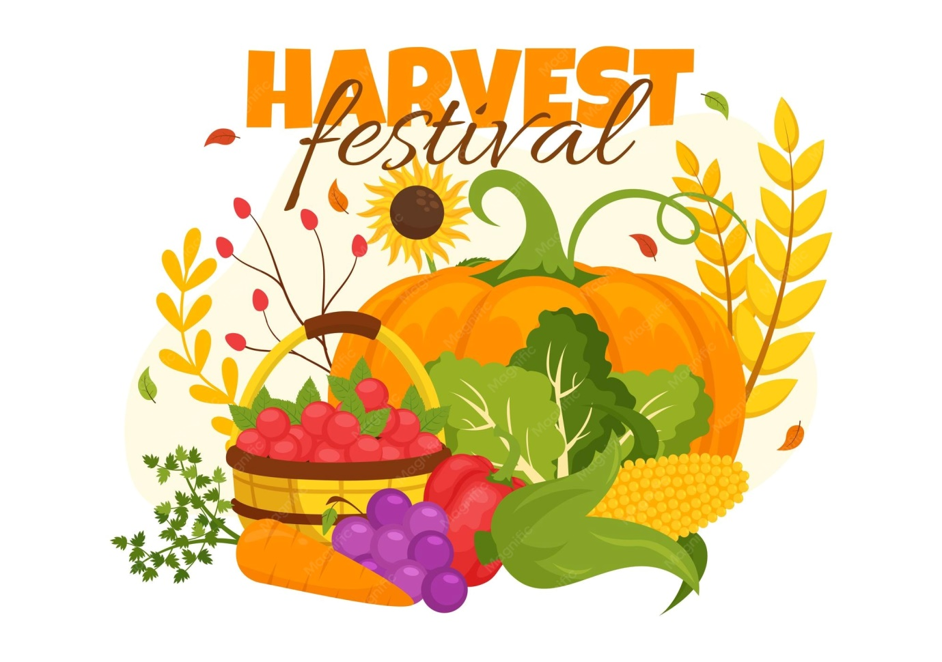

Sunday 20th September
11am
St Botolph’s Church Beauchamp Roding
All welcome to celebrate Harvest with us
Come and meet our new Vicar
Revd Tim Goodbody
Harvest gifts will be gratefully received in aid of Harlow foodbank. Tinned foods, rice, pasta, tea bags, coffee particularly welcome.

