Join us for our Sunday Service
September Services
6th 11am Holy Communion
13th 9.30am Holy Communion at our partner Church St Margaret’s, Orford Green, Warrington WA2 8PH
20th 11am Holy Communion
27th 11am Holy Communion
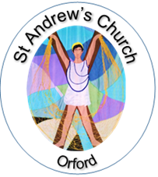

https://www.achurchnearyou.com/church/15284/
or find us on Facebook

