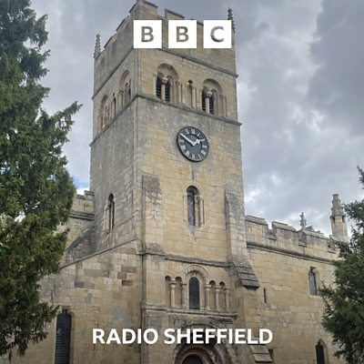
DID ROBIN HOOD GET MARRIED IN DONCASTER (CAMPSALL)?

BBC SOUNDS PODCAST
Secret South Yorkshire

As Churchwarden of St Mary Magdalene Church here in Campsall, I was recently contacted by Jack Hadaway-Weller from BBC Sheffield to talk about the legend that is Robin Hood. In particular his connection with our church here in Campsall and the marriage to Maid Marian.

There are usually two sides to a story, so I asked Howard Connell who has done extensive historical research on Robin Hood to join me.

Please listen either via your Smart TV, media player, iPhone etc.
This Podcast will be available for the next twelve months.

Christine – Warden
August 2026

