Donated dry goods will be taken to the Norwich Food Bank and fresh produce to
St Martins Housing.

Bring your donations to the service, or
to decorate the church for Harvest
on Saturday
3rd October
9.30
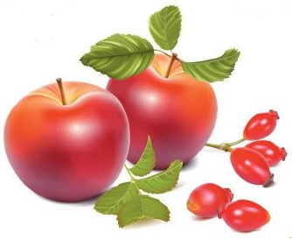

Bergh Apton
Church

Sunday 4th October
10:00 am
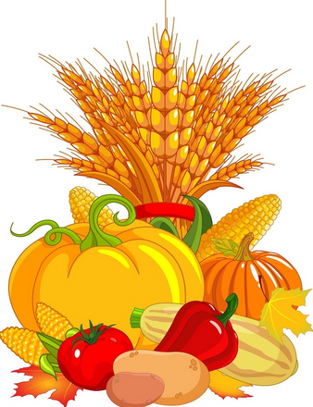
Harvest
Festival

