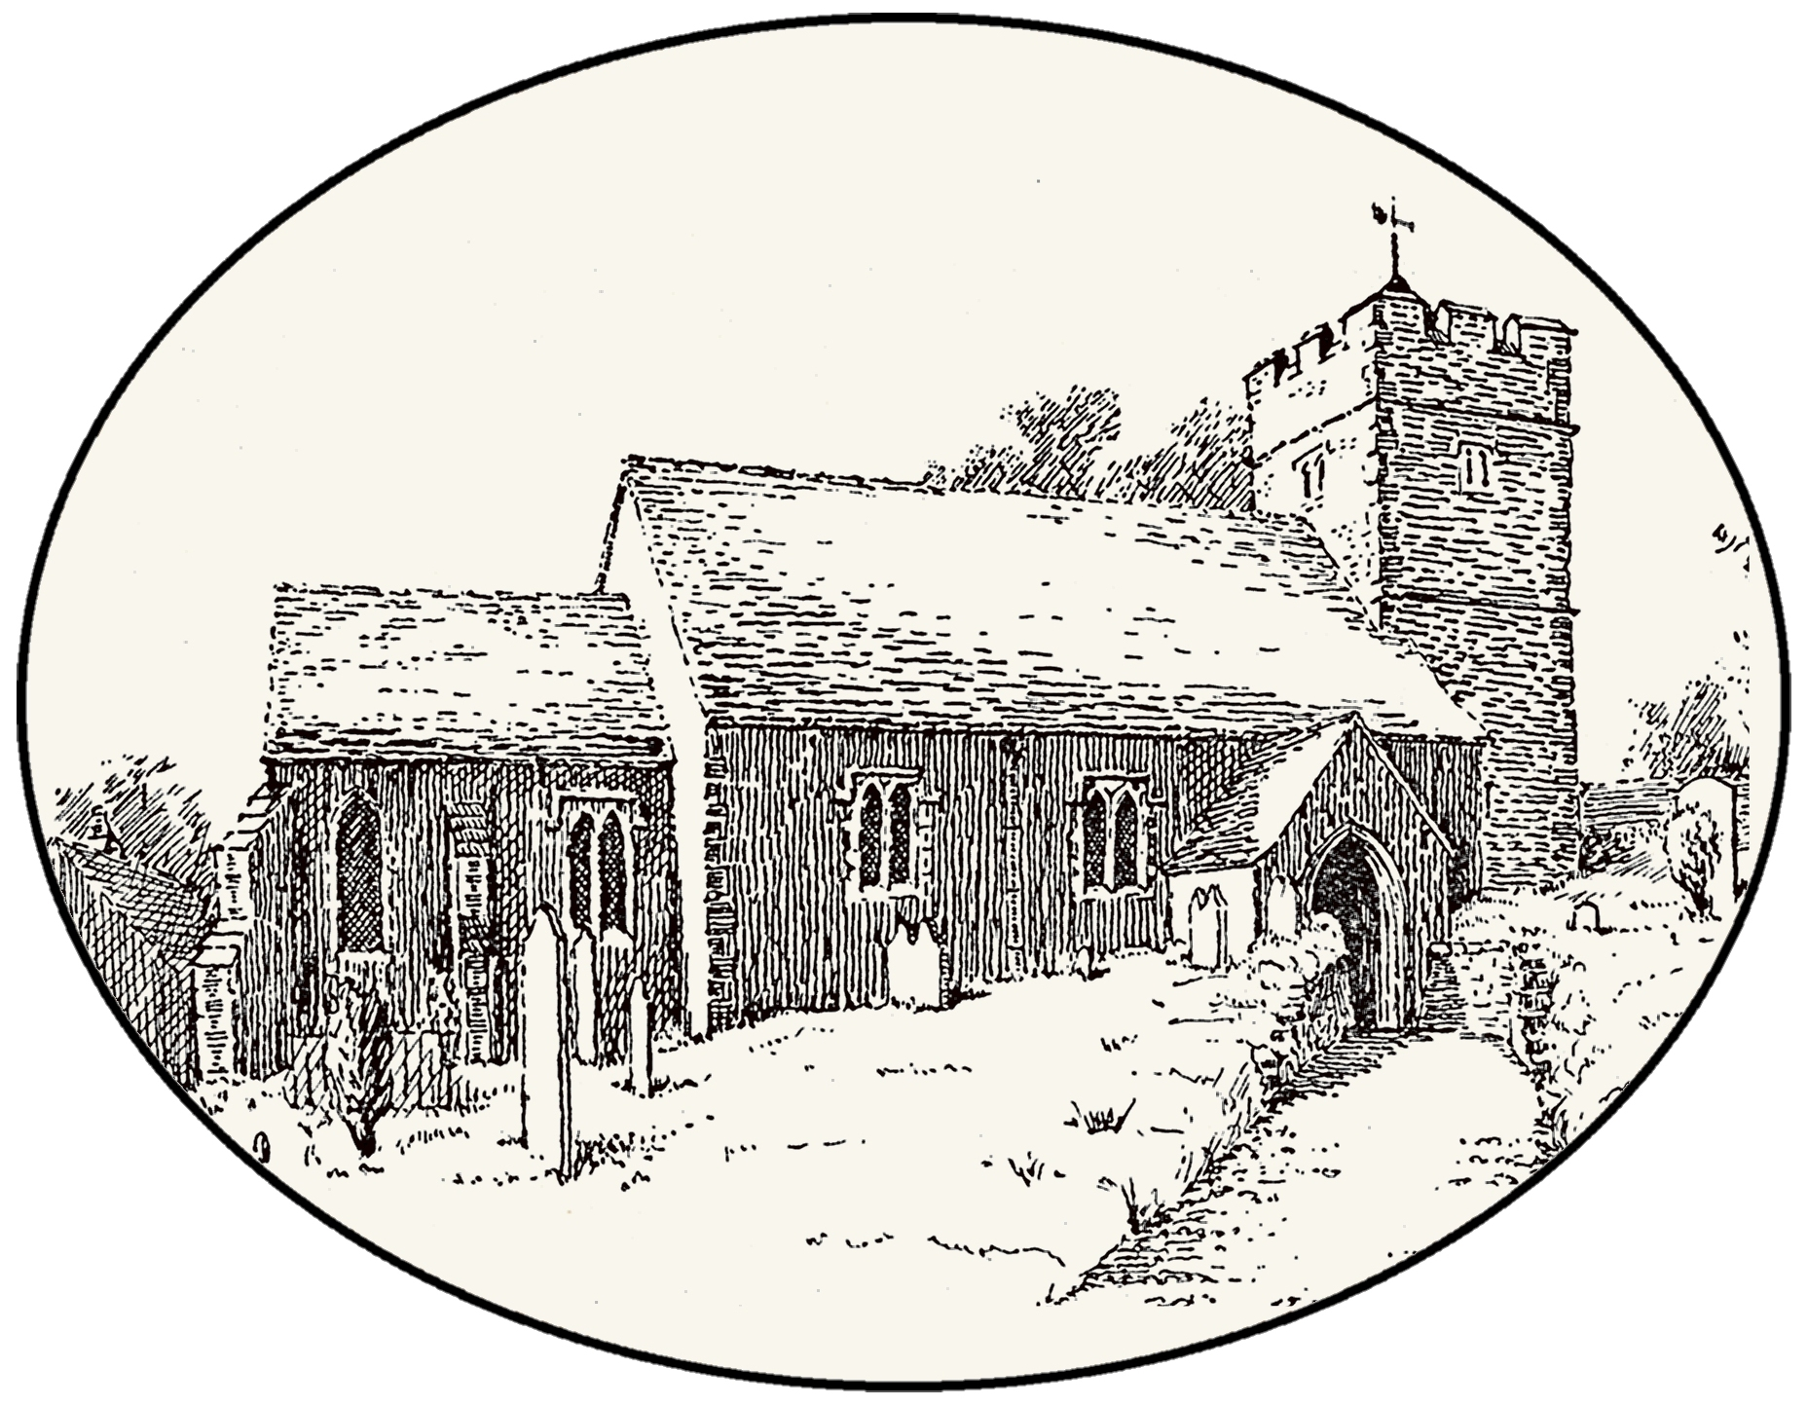
The Church of St. Michael & All Angels, Cuxton

Invites you to celebrate
St. Michael’s Day - “Michaelmas”
With an evening of history and music
The programme:
- Part 1: A talk on the early history of St. Michaels, from Roman times to the English Reformation (7.00pm to 7.30pm)
- A church organ recital by local musician and organist Janet Stone (7.30pm to 7.50pm)
- A break for light refreshments (soft drinks and snacks will be provided – 7.50pm to 8.15pm)
- Part 2: The history of St. Michaels, post-Reformation to the present day (8.15pm to 8.45pm)
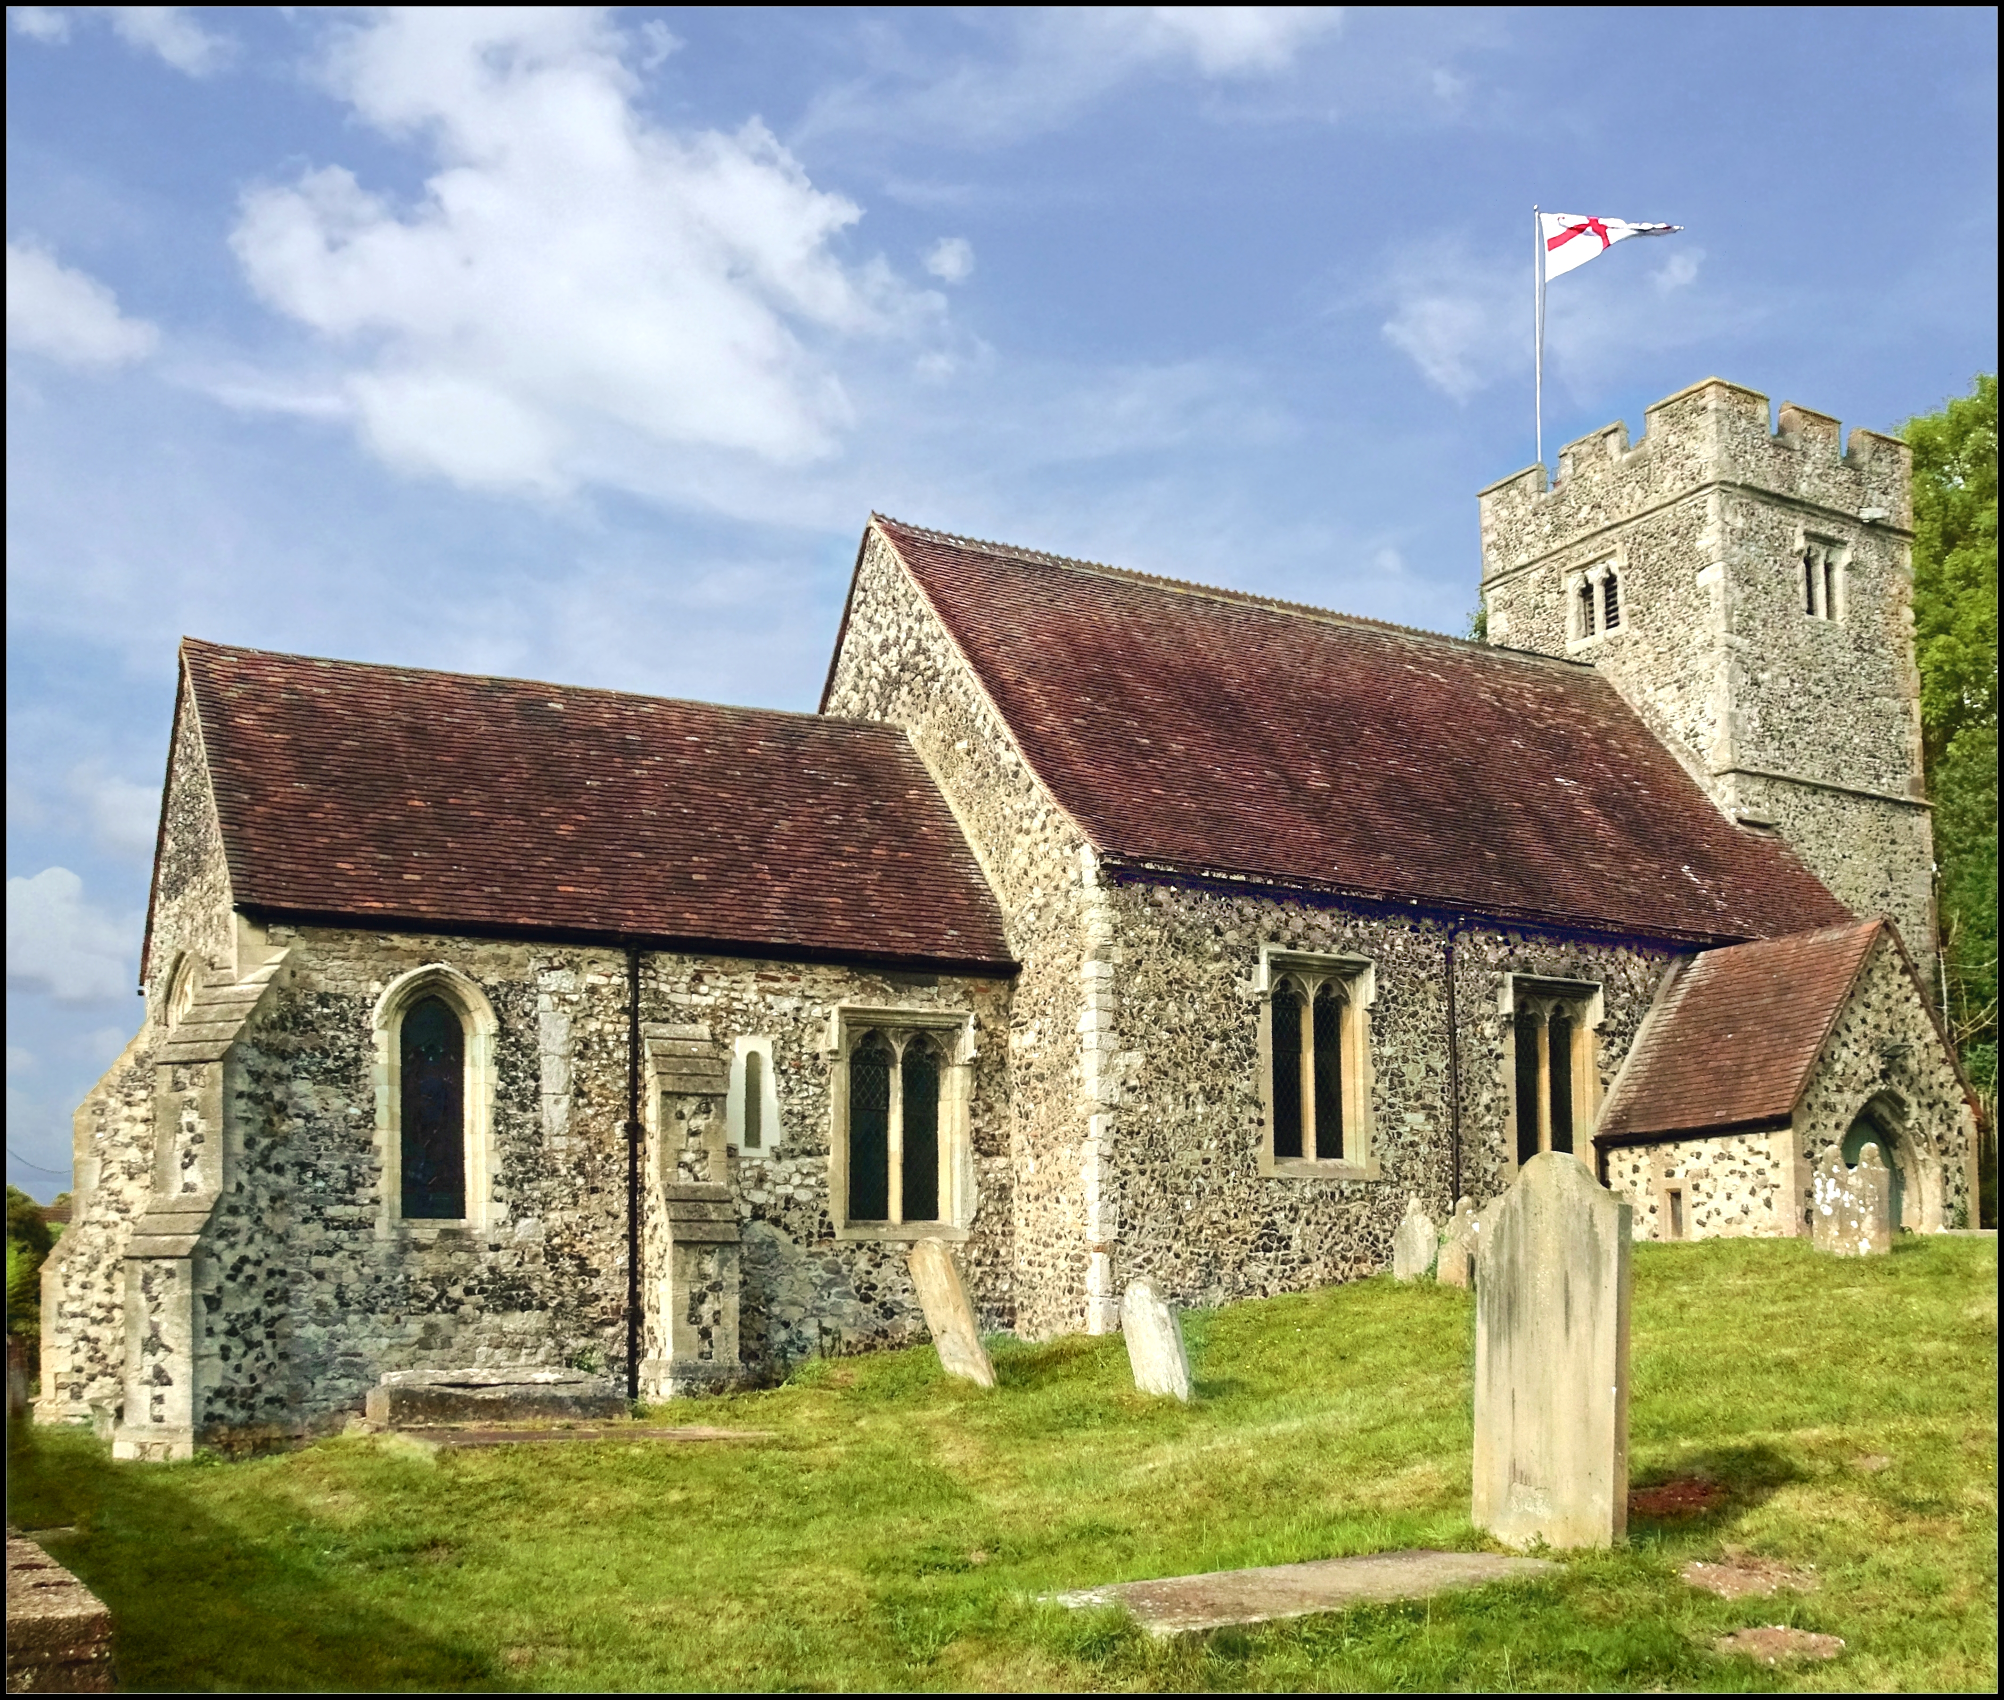
Tuesday 29th September 2026
7.00 pm to 9.00 pm, at the church of St. Michaels and All Angels, Rochester Road, Cuxton ME2 1AF
All Welcome. Free admission
(though donations for church funds will be greatly appreciated!)

