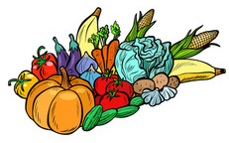

HARVEST SUPPER

SATURDAY 3rd OCTOBER

6:00PM

ROYSTON PARISH CHURCH

Tickets £12 individual / £30 family

Supper includes casserole, cottage pie or vegetarian alternative, with fruit crumble for dessert.
Drinks available to buy.

To book please go to  https://tickets.myiknowchurch.co.uk/gb/NzcwMi0zNw/t  or scan the QR code  Entertainment included | 

