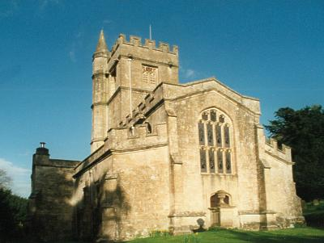
BRATTON CHURCH
BELL TOWER VISIT AND TEAS
SATURDAY 25TH JULY
2 PM TO 4 PM
WE WELCOME EVERYONE FOR A GUIDED TOUR OF ST JAMES’ CHURCH BELL TOWER INCLUDING THE RINGING CHAMBER AND BELL CHAMBER.
COME AND ENJOY TEA AND CAKES AS WELL
