
Your Bible is not just for Sunday
Parables of Jesus
Sunday    The Rich Fool  Luke 12:16-21 | Monday    Hidden Treasure  Matthew 13:44 | Tuesday    New Cloth on Old Garment  Mark 2:21-22 | Wednesday  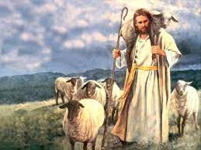  The Lost Sheep  Matthew 18:10-14 | Thursday    The Good Samaritan  Luke 10:29-37 | Friday    The Weeds and Wheat  Matthew 13:24-30 | Saturday    The Sower  Mark 41-20
Every day is a Bible day
Spend time each day with God.

