
Your Bible is not just for Sunday
Old Testament Miracles
Sunday  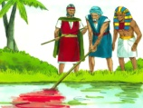  Exodus 7-11  The 10 Plagues of Egypt | Monday  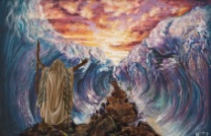  Exodus 14  The Parting of the Red Sea | Tuesday  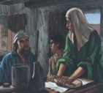  1 Kings 17:14-24  The Widow at Zarephath | Wednesday  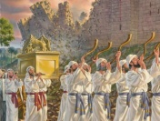  Joshua 6  The Fall of Jericho | Thursday  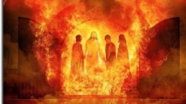  Daniel 3;19-27  The Fiery Furnace | Friday    Daniel 5  Belshazzar’s Feast and the Writing on the Wall | Saturday  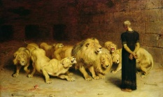  Daniel 6:16-23  Daniel in the Lions’ Den
Every day is a Bible day
Spend time each day with God.

