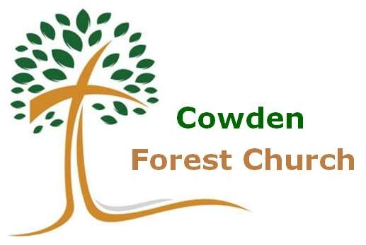

Sunday July 26th

3.30 to 4.30pm

A family time of worship and activities in church and outside, as we celebrate God’s creation.

Songs, crafts, story prayers, tea and cakes.

Come dressed for the great outdoors!

Meet in Cowden church at 3.30pm
NO FOREST CHURCH IN AUGUST

