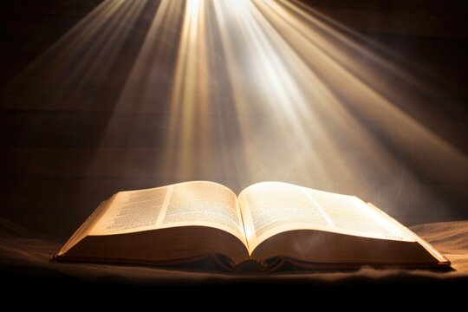
Your Bible is not just for Sunday
Miracles of the New Testament
Sunday  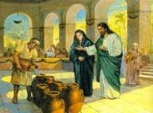  John 2:1-11  Jesus Turns Water Into Wine | Monday    John 5:43-54  Jesus Heals the Official’s Son | Tuesday  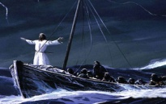  Mark 4:35-41  Jesus Calms the Storm | Wednesday  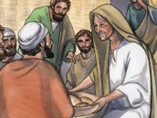  Luke 4:38-39  Jesus Heals Peter’s Mother-in-Law | Thursday  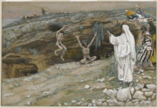  Matthew 8:28-34  Jesus Heals the Demon-Possessed Men | Friday  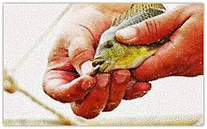#  Matthew 17:24-27  The Temple Tax  Paid | Saturday  who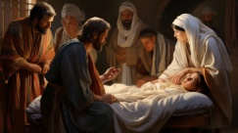  Mark 5:21,35-43  “Talitha Koum!”  Raising of Jairus’Daughter
Every day is a Bible day
Spend time each day with God.

