HELP US FILL A SUITCASE WITH HOPE!

Zimbabwe Mission Trip 2026
This August, a team from Mission Direct will be travelling to Bulawayo, Zimbabwe, to support schools, families, mothers, babies and community projects.
You can help by donating practical items or making a financial contribution to purchase supplies locally.

BRING ITEMS TO DONATE

For Hope Schools
• Children’s school shoes • English and Science revision books • Pens, pencils and colouring pencils • Exercise books • Rubbers and sharpeners • School bags and rucksacks

For Families and Community Projects
• Story books • Finger puppets • Footballs and pumps • Stationery items • Small hand sanitisers

For Mothers and Babies
• Tiny baby clothes (up to 3 months) • Baby blankets • Small towels • Maternity pads • Crochet octopuses and soft toys • Wool and knitting needles • Formula milk

HELP US BUY ITEMS IN ZIMBABWE
Every pound goes a long way.

💜 £5 – Stationery for a child
💜 £10 – Baby care supplies
💜 £20 – Food for a vulnerable family
💜 £50 – Paint and decorating supplies
💜 £100 – Building materials for classrooms
💜 £250 – Support the Hope School feeding programme

WHY IT MATTERS
Hope Primary School has grown from 40 pupils to around 450 children.
Hope High School now serves 120 students.
Many children come from rural villages and township communities where families face significant financial hardship. Together we can help create safe classrooms, provide learning resources, support families and give young people the opportunity to flourish.

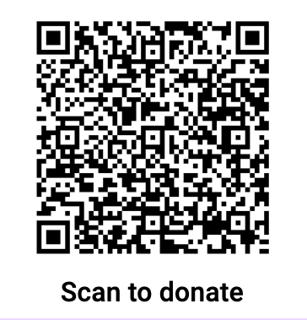
DONATE • PRAY • ENCOURAGE
Every item. Every pound. Every prayer.
Together we can help build hope in Zimbabwe.
For more information or to donate:
Contact: Joanna Smith 07980558021

