Feast of the Transfiguration
when Jesus is revealed in glory on the mountain, with Moses and Elijah appearing beside him, revealing that Jesus
is truly the Son of God
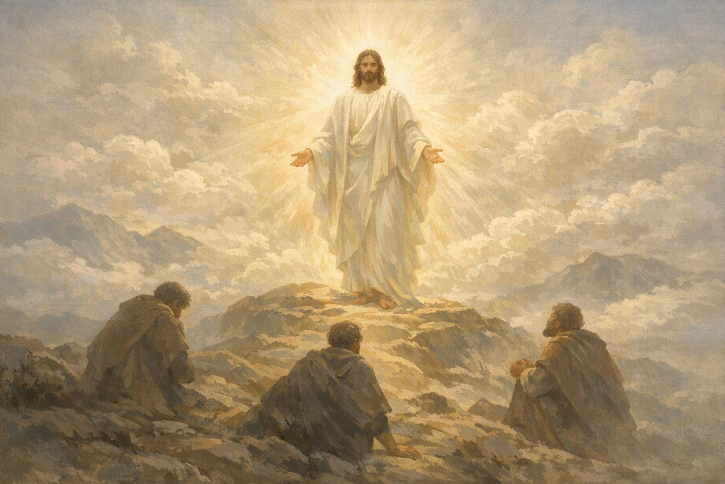

St Mary and St Michael’s Egremont

Thursday 6th August 2026 at 6pm
“This is my beloved Son… listen to him.”
Matthew 17:5
Join us for worship, prayer, and thanksgiving.
All are welcome to share in this feast of light and glory. “Lord, it is good for us to be here.”



