CAR BOOT SALE
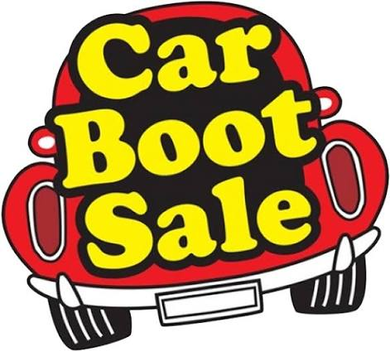
AT ST.LUKES CHURCH LOSCOE
SATURDAY 8 AUGUST
10.00-2.00 PM
HELD ON THE CHURCH
DRIVE (IF BAD WEATHER WILL BE HELD INSIDE CHURCH)
PITCHES £5 - ADVANCED BOOKING ONLY
PLEASE RING : 07891136055 TO BOOK

