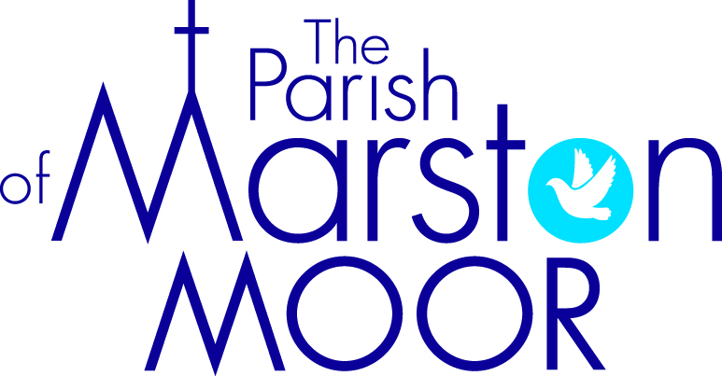 | Askham Richard | Bilbrough | Long  Marston | Rufforth | Tockwith
2nd  9th Sunday after Trinity | Tockwith Show Service  10.30am
2nd  9th Sunday after Trinity | Parish Holy Communion  Rufforth – 11.00am
9th  10th Sunday after Trinity | 9.00am  Holy Communion | 10.00am  Parish Praise | 5.00pm  Holy Communion | 11.00am Worship Together | 11.00am  Creative Communion
16th  11th Sunday after Trinity | No Service (Summer fair) | 9.00am  Holy Communion | 11.00am  Creative Church | 11.00am  All Age Worship | 6.00pm  BCP Communion
23rd  12th Sunday after Trinity | 9.00am  Holy Communion | 10.00am  Family Praise | 11.00am  All Age Worship | 11.00am  Holy Communion | 11.00am  Informal Parish Praise
30th  13th Sunday after Trinity | Parish Holy Communion  Tockwith  10.00am

