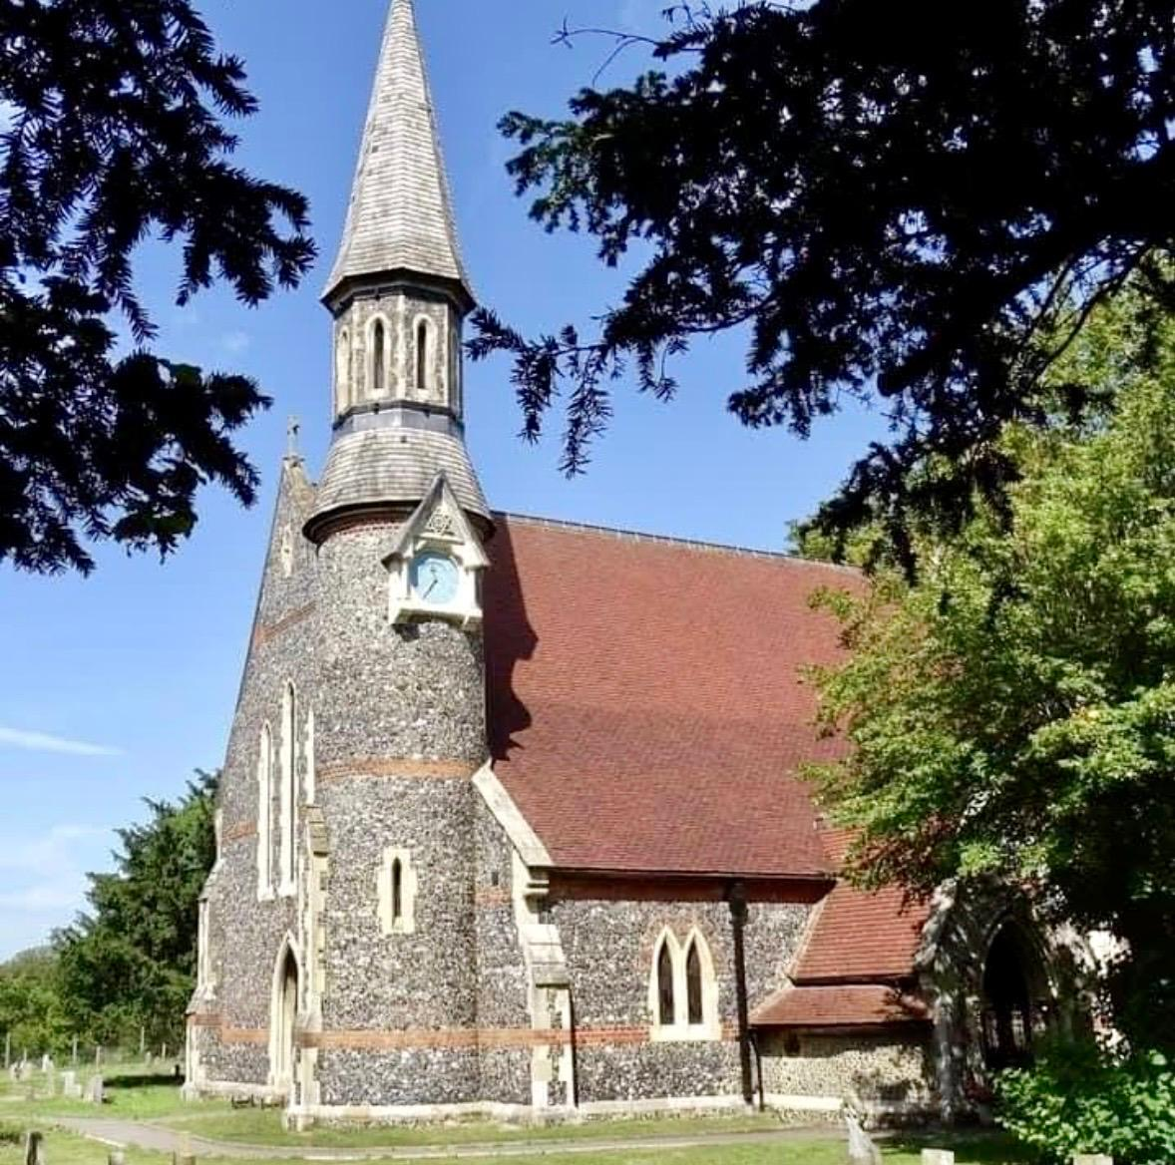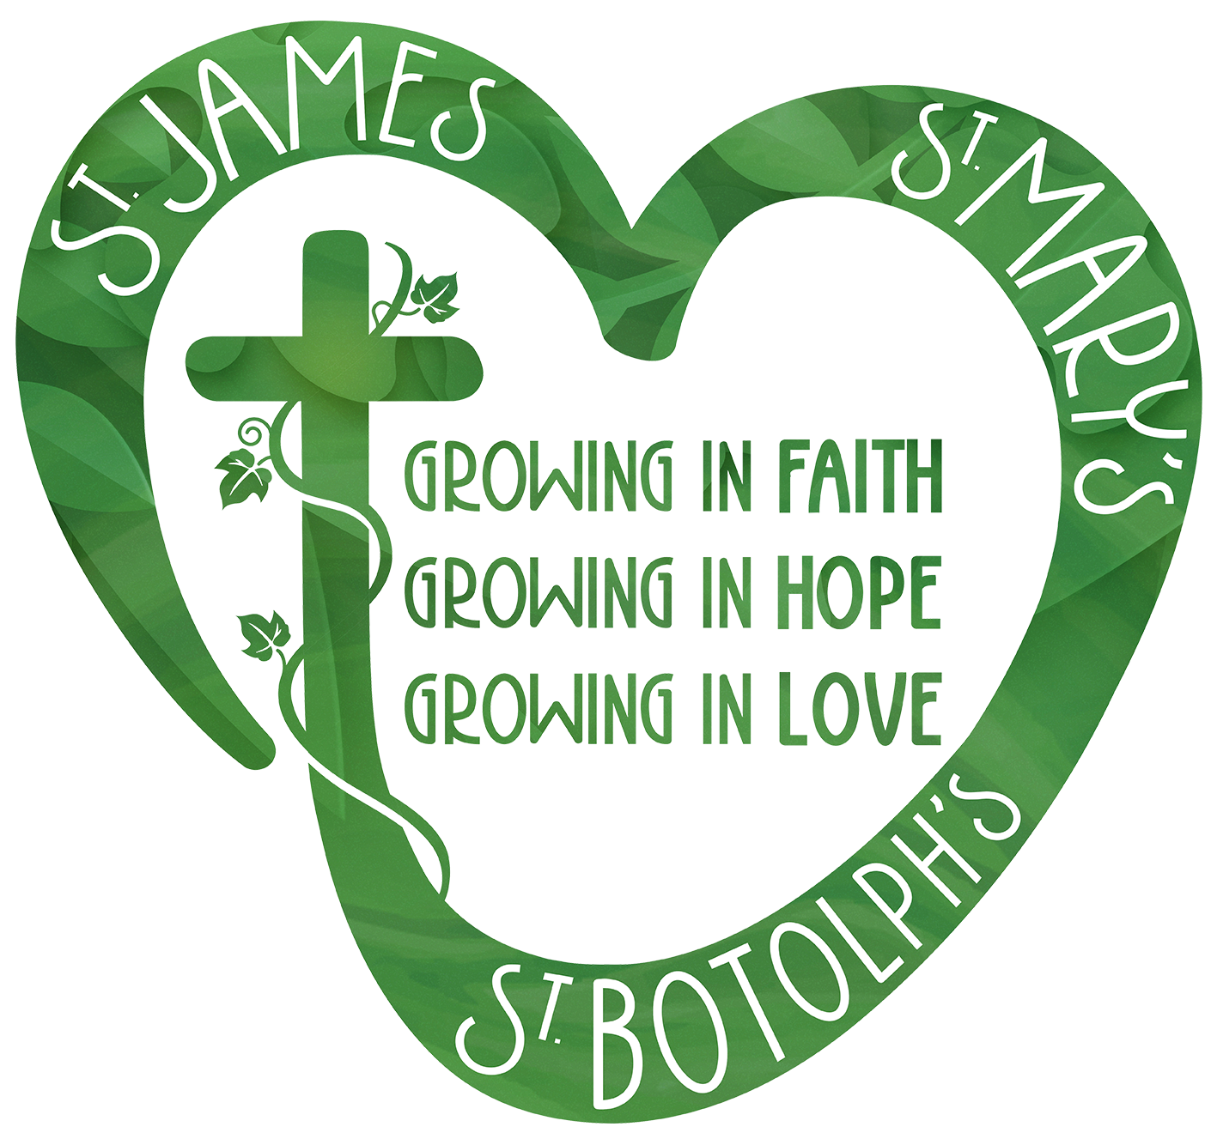

Generosity & Giving at St James
A four-week church journey beginning Sunday 14 June

This June, we’ll be sharing together in a four-week Generosity & Giving Opportunity as part of our life at St James.
This is not a fundraising campaign in the usual sense. Instead, it is an invitation for each of us to pause, reflect, and think prayerfully about giving as part of our faith and discipleship.
For some, this may be an opportunity to increase their giving. For others, giving may stay the same. And for some, this could be the beginning of regular giving for the first time.
What matters most is that each of us responds thoughtfully and prayerfully.

Why are we doing this?

1. Being open about our finances
Like many churches, St James relies both on regular giving and fundraising. Fundraising events are important and enjoyable, but regular committed giving is what sustains the everyday ministry and mission of the church.

2. Generosity as part of discipleship
Generosity is about far more than money. It is part of our spiritual life — a response to God’s generosity to us. Giving can reflect gratitude, trust, and hope.

3. Supporting the vision of St James
Everything we do — worship, pastoral care, outreach, hospitality, and community life — is made possible through the faithful generosity of our church family.
This is an opportunity to reconnect our giving with the future vision and mission of St James.

Looking ahead
During the four weeks, we’ll share more about:
• how giving supports the life of the church
• simple and sustainable ways to give
• the Parish Giving Scheme and regular giving
• the future vision and priorities of St James
We’ll also encourage those who are able to consider regular giving as one of the most effective ways to support the ongoing ministry of the church.

A shared journey
This is something we are doing together as a whole church community.
Our hope is that this time will help us grow not only in generosity, but also in our shared sense of purpose and calling.
Above all, this is about strengthening generosity as part of our faith — not simply balancing the books.

Should you wish to make a donation, please use the QR code below:


