
Your Bible is not just for Sunday
Prophesies of Jesus in the Old Testament
Sunday    Micah 5:2  Bethlehem | Monday    Hosea 11:1  Flight into Egypt | Tuesday    Jeremiah 31:15  Massacre | Wednesday  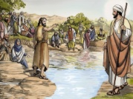  Isaiah 40:3-5  Prepare the Way | Thursday    Isaiah 61:1-2  Prophesy Fulfilled | Friday    Zechariah 9:9  Behold Your King | Saturday    Isaiah 53  Trial and Death of Christ
Every day is a Bible day
Spend time each day with God.

