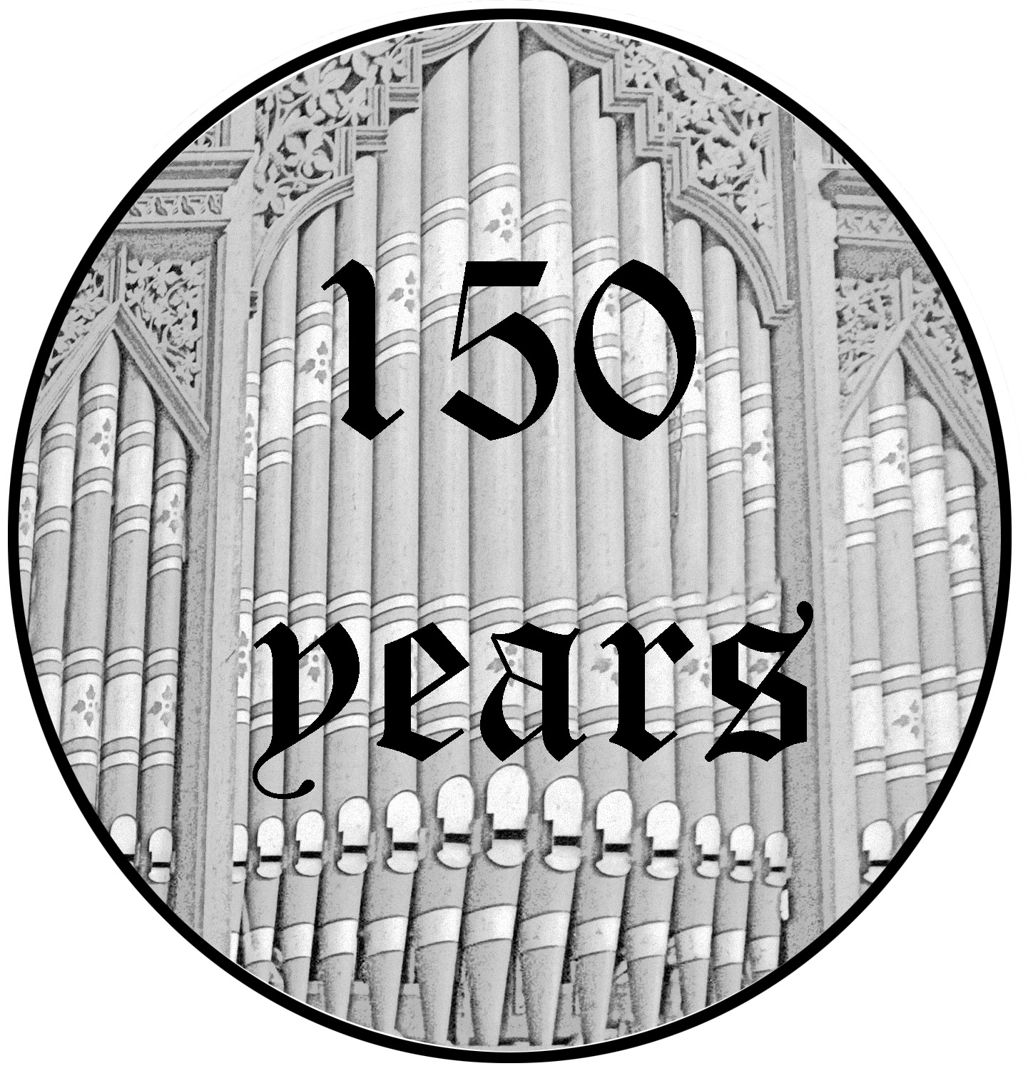
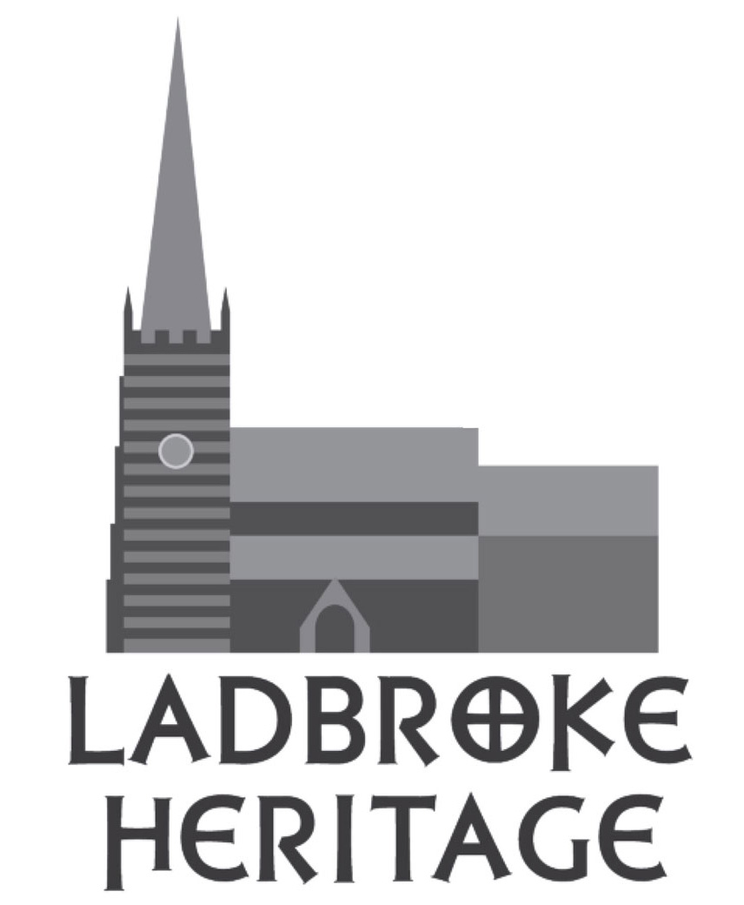
Celebrating the 150th birthday
of Ladbroke’s Pipe Organ

Concert
♪
♪
♪
♪
by
Kantorei Prenzlau
& friends

including Bach’s Toccata in D minor &
works by Saint-Saëns, Vivaldi, Elgar & Mendelssohn
Organist & choir’s musical director : Hannes Ludwig

Free admission with retiring collection

Saturday 11th July
3pm

Ladbroke Church
CV47 2DF

ladbrokeheritage.org.uk ladbrokechurch.org.uk

