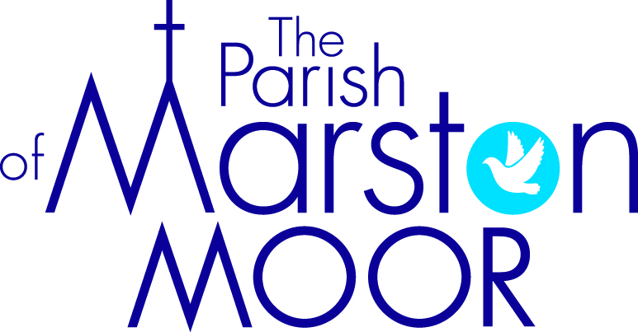 | Askham Richard | Bilbrough | Long  Marston | Rufforth | Tockwith
5th  5th Sunday after Trinity |  | 9.00am  Holy Communion | 8.30am  Breakfast Praise | 11.00am  Holy Communion | 11.00am  Refresh Service
12th  6th Sunday after Trinity | Parish Holy Communion in Tockwith  We will come together to support Karen as she celebrates her first Holy Communion in our churches. (Followed by a bring and share lunch)  11.00am
19th  7th Sunday after Trinity | 10.00am  All Age Worship | 9.00am  Holy Communion | 11.00am  Creative Church | 11.00am  All Age Worship | 6.00pm  BCP Evensong
26th  8th Sunday after Trinity | 9.00am  Holy Communion | 10.00am  Family Praise | 11.00am  All Age Worship | 11.00am  Holy Communion | 11.00am  Informal Parish Praise

