
Your Bible is not just for Sunday
Caring for God’s World
Sunday    Genesis 1:1-2:3 | Monday    Leviticus 25:1-24 | Tuesday    Jeremiah5:23-25 | Wednesday  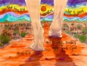  Micah 6:1-8 | Thursday    Matthew 6:9-13 | Friday    Romans 8:19-21 | Saturday    Colossians 1:15-20
Every day is a Bible day
Spend time each day with God.

