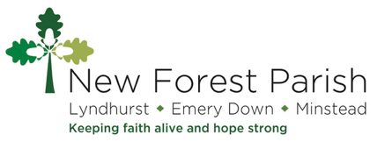
CHILDREN AND FAMILIES

CALENDAR
Feb | THEME We Are All Loved! ️  7th Messy Crafts  13th INSET DAY  15th Mickey’s House  22nd Funday Sunday | Jul | THEME He’s Got The World In His Hands!  4th Messy Crafts  12th Mickey’s House  26th Funday Sunday
Mar | THEME Let Us Bee …  7th Messy Crafts  15th Mickey’s House  22nd Funday Sunday | Aug | THEME Come Fishing – Jesus Calls His First Disciples  1st Messy Crafts  9th Mickey’s House  23rd Funday Sunday
Apr | THEME EASTER – ‘He Is Alive! – Let’s Celebrate!’  4th Messy Crafts  12th Mickey’s House  26th Funday Sunday | Sep | THEME Let’s Go Exploring!  5th Messy Crafts  13th Mickey’s House  27th Funday Sunday
May | THEME Happy Birthday!  2nd Messy Crafts  10th Mickey’s House  24th Funday Sunday | Oct | THEME Celebrating Harvest  3rd Messy Crafts  11th Mickey’s House  25th Funday Sunday
Jun | THEME Jesus Our Super Hero! ‍️  6th Messy Crafts  14th Mickey’s House  28th Funday Sunday | Nov | THEME Walking In The Light  7th Messy Crafts  15th Remembrance Day  22nd Funday Sunday
Dec | THEME Celebrating Christmas – A Baby Is Born – Ring Out The Good News!  5th Messy Crafts  13th Mickey’s House  27th Funday Sunday
www.newforestparishes.com

