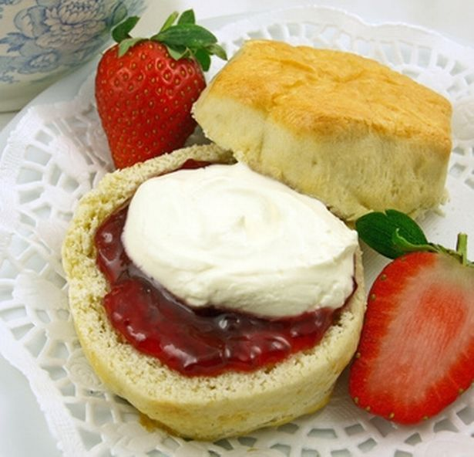
George Orwell Afternoon
Sunday 28th June 2026
Cream Teas - 2:30-5:30pm.
£5 per person
3pm - Act of Commemoration at the Grave of Eric Arthur Blair with the Orwell Society
The River Room
All Saints’ Church
Sutton Courtenay, OX14 4AE
All welcome!

