The Benefice of Garsington, Cuddesdon and Horspath

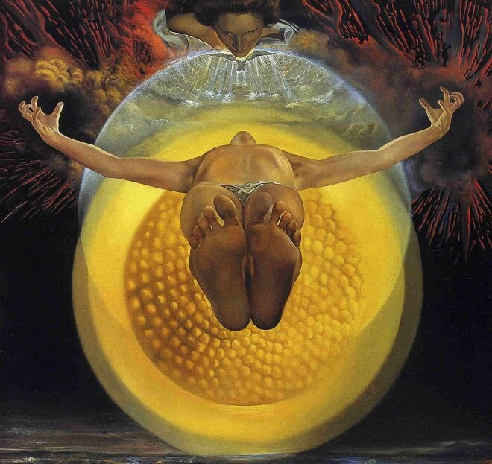

The Ascension of Christ, 1958 by Salvador Dali

A service of Holy Communion for Ascension Day at St Mary’s Garsington, 6.00pm Thursday 14th May, followed by refreshments.
Everybody is very Welcome

