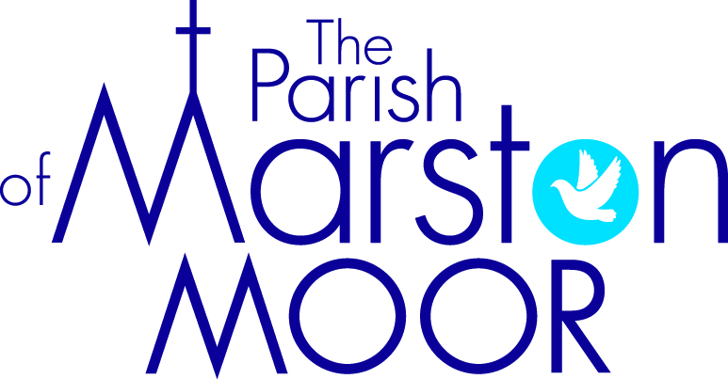 | Askham Richard | Bilbrough | Long  Marston | Rufforth | Tockwith
7th  1st Sunday after Trinity |  | 10.00am  Pet Blessing Service | 8.30am  Breakfast Praise | 11.00am  Holy Communion | 11.00am  Refresh Service
14th  2nd Sunday after Trinity | 9.00am  Holy Communion | 10.00am  Parish Praise | 5.00pm Holy Communion | 11.00am  Worship Together | 11.00am  Creative  Communion
21st  3rd Sunday after Trinity | 10.00am  All Age Worship | 9.00am  Holy Communion | 11.00am  Creative Church | 11.00am  All Age Worship | 6.00pm  BCP Communion
28th  4th Sunday after Trinity | 9.00am  Holy Communion | 10.00am  Family Praise | 11.00am  All Age Worship | 11.00am  Holy Communion | 11.00am  Informal Parish Praise
28th June Karen’s Ordination to the Priesthood – Selby Abbey, 6.00pm – ALL WELCOME

