
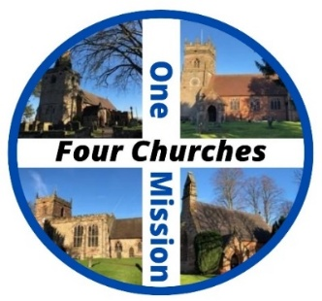
The United Benefice of
Bradley
Church Eaton, Derrington
and Haughton
20th Anniversary Celebrations!
3rd – 10th May 2026

It is now 20 years since our four churches began worshiping, praying and working together as a United Benefice.
Lots of things have happened over those 20 years and so we will be celebrating our achievements by encouraging everyone to visit our churches to learn a little bit more about them and then joining together to bless each of our churches and communities when we ‘clip’ each of our churches on Sunday 10th May.

How do you clip a church? We will make a big circle around the outside of the church and thank God for all that has happened there since it was built and for all that is happening today, we then face away from church and pray for our communities….its a bit like giving our churches a big Hug!

Our services for 10th May are as follows:

9am Morning prayer and clipping with breakfast Church Eaton
11am Holy Communion and clipping Haughton
1.30pmm Clipping with Teddy and Dolly and cake Bradley*
4pm Joyful noise Clipping and BBQ Derrington

Our churches are special places in our communities so come and give them a Hug as we celebrate together!

*Bishop Michael is hoping to join us at Bradley!

