Teddy and Dolly Church
A new church service for children and adults of all ages!
Every 3rd Sunday at 4pm at St Giles Haughton
(this will replace our 6pm evening service)
With the help of Teddy and Dolly (and our imaginations) we will explore some well-known bible stories and our own relationship with God.
For more information, please contact Rev’d Cath
Please note that all children need to be accompanied by a responsible adult.
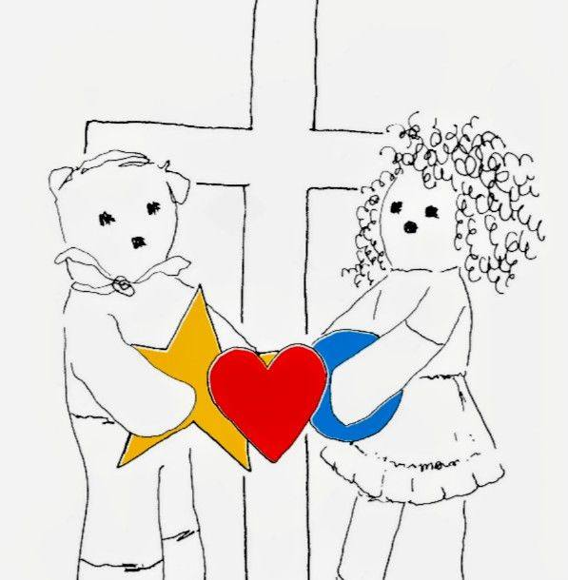

Teddy and Dolly Stories and illustrations ©Reverend Liz England2026

