
Worship at
St Botolph’s
for Pentecost
Sunday May 24th
4.00pm
A time of reflection
in the style of Taizé
This style of prayer and praise originated in a community in France, attracting many people from every Christian tradition
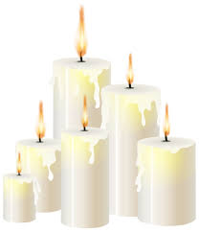
to the simplicity of candle-lit worship.
‘The Holy Spirit came like wildfire’ Acts 2

