Hymns and Pimms
on a Summer’s Evening

  - Join us for a delightful evening of favourite hymns and refreshing Pimms
Date: Sunday 19th July 2026
Time: 18:00
Venue: All Saints’ Church, Sutton Courtenay
Entry is free, but donations welcome towards the Tower and Bells Appeal, helping to upgrade the interior of the church tower and to restore the bells for generations to come.
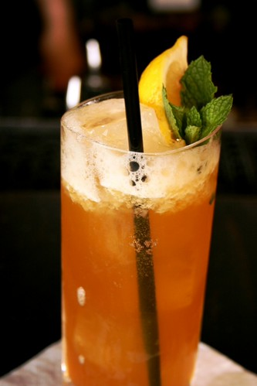
Bring your friends and family—everyone is welcome!
You will be invited to drop the number of your favourite hymn into a hat and to wait and see if it is picked and then sing along with gusto. Or you can just enjoy the music, soak up the summer atmosphere, and raise a glass for a good cause. More information from admin@damascusparish.org.uk

